Policy No: 1(A).1

LIFE Wirral Sports School

Safeguarding Policy and Procedure
This policy, which applies to the whole school, is publicly available on the school website and upon request a copy (which can be made available in large print or other accessible format if required) may be obtained from the Designated Safeguarding Lead.
Document Details
Information Sharing Category | Public Domain
Version | V2
Date Published | September 2022
Authorised by (if required) | Chief Executive Officer
Review / Update Date | September 2023
Responsible Area | Safeguarding Team

Keeping Children Safe in Education (KCSIE) (DfE: September 2022) is referred to is this policy as KCSIE (currently in force),

We have a whole school approach to safeguarding, which is the golden thread that runs throughout every aspect of the school. All our school policies support this policy.

In our school the children are referred to as pupils. Therefore the using the term ‘child’ or ‘pupil’ is interchangeable in this policy

Safeguarding is everyone’s responsibility. All who work, volunteer or supply services to our school have an equal responsibility to understand and implement this policy and its procedures both within and outside of normal school hours including activities away from school. All employees and volunteers are required to sign that they read, understood and will abide with our Child Protection Policy, ‘KCSIE Part 1 inclusive of Annex A’ along with our Low Level Concerns Policy, Safer Recruitment Policy, Whistleblowing Policy, Staff Behaviour Policy (Staff Code of Conduct), and The Teachers’ Standards. This policy takes full account of the child protection procedures agreed by the Wirral Safeguarding Partnership. We will always act in the best interests of the child. The Life School recognises it is an agent of referral and not of investigation. Any person may make a referral (including whistleblowing) to external agencies such as the Local Authority Designated Officer (LADO) and the police, if necessary. The Life School also allows access for children’s social care from the host local authority and, from the local authorities where the children reside in undertaking their safeguarding (Child Protections) duties.

Monitoring and Review: This policy is subject to continuous monitoring, refinement and audit by Mrs. Sarah Quilty who is the Designated Safeguarding Lead (DSL) and Mr Colin Lamprey who is the Deputy DSL. The Advisory Board will undertake a full annual review of this policy and its procedures, inclusive of the implementation and efficiency with which the related duties have been discharged. This discussion will be formally documented in writing. The Advisory Board recognise the expertise staff build by undertaking safeguarding training and managing safeguarding concerns. As such, staff have the opportunity to contribute to and shape our safeguarding arrangements and child protection policy. Any deficiencies or weaknesses recognised in arrangements or procedures will be remedied immediately and without delay. All staff will be informed of the updated/reviewed policy and it is made available to them in either a hard copy or electronically on the staff share drive. This document was reviewed and agreed by the Advisory Board in September 2022 and if significant changes to the systems and arrangements take place, or if legislation, regulatory requirements or best practice guidelines so require, prior to September 2023, the policy will be reviewed accordingly

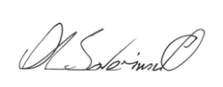
Signed:
Sarah Quilty Alastair Saverimutto
Headteacher Chief Executive Officer and Chair of the Advisory Board

Our school has a Proprietor, known as the Chief Executive Officer who takes seriously their responsibility under Section 157 of the Education Act 2002 to safeguard and promote children’s welfare; to work together with other agencies to ensure adequate arrangements within our school to identify, assess and support those children who are suffering harm. The Chief Executive Officer has ensured that the appointment as DSL states that part of the duties of the post involve contacting the Local Authority Designated Officer (LADO) on any matter that the DSL considers cannot be properly dealt with internally. The DSL can directly access advice as required.

Our child protection policy forms pages 1 to 23 of this document. There is a separate document that contains appendices to the main Child Protection Policy. We also have separate comprehensive documents on Safer Recruitment and Staff Selection, Sexual Violence and Sexual Harassment (child- on- child abuse). The Advisory Board recognise the expertise staff build by undertaking safeguarding training and managing safeguarding concerns. As such, staff have the opportunity to contribute to and shape our safeguarding arrangements and child protection policy. Any deficiencies or weaknesses recognised in arrangements or procedures will be remedied immediately and without delay

Page Contents
- Preamble, Monitoring and Review;
2. Key Internal Contacts;
3. Key External Contacts;
4. Record of Safeguarding Training, Safeguarding Procedure, Allegations against the DSL, Staff, volunteers or the Advisory Board;
5. Dealing with a disclosure made by a Child, Making a referral;
6. Unsubstantiated, false or malicious allegations, Low-Level Concerns, Record Keeping
7. Discussing Concerns with the Family and the Child, Introduction and Our Ethos;
8. Scope and Legal Framework, Roles and Responsibilities;
9. Thresholds, Early Help;
10. Child in need, Children act, Working with our Safeguarding Partners, Contextual safeguarding;
11. Serious Violence, Concerns and allegations of abuse made against other children (Peer on Peer Abuse inclusive of sexual violence or harassment;
12. Peer-on-peer abuse, Minimising the risk of peer-on-peer abuse
16. Supporting children
17. Supply teachers, Safeguarding arrangements during mandatory school closures / remote working (such as COVID-19);
18. Staff Induction, Training and Development;
19. Teaching Pupils how to Keep Safe, Online Safety;
20. Confidentiality and Information Sharing, Inter-agency working, Notifiable Incidents;
21. Pupils being withdrawn from school, Listening to the wishes of children and young people, Pupil Mental Health, Pupils who are particularly vulnerable;
22. Safeguarding disabled pupils and pupils with medical conditions, Staff Behaviour Policy, Contractors, Disclosure and Barring Service, Whistleblowing, Complaints;
23. Site Security, Quality Assurance;
24. Appendix A – The Role of the Designated Safeguarding Lead;
26. Appendix B – Safeguarding Information;
27. Categories of Abuse;
28. Thresholds and Referrals;
29. Appendix C – Further Information (Additional Safeguarding Issues);
44. Appendix D – Flowcharts and LSCP Information

KEY INTERNAL CONTACT DETAILS
Our School’s Designated Safeguarding Lead (DSL) and the Deputy DSL, who are members of the Senior Leadership Team (SLT), have lead responsibility for child protection and are also the Prevent Officer and Deputy Prevent Officer responsible for the prevention of radicalisation, extremism and being drawn into terrorism. Their telephone numbers are prominently displayed in the school. The LIFE Wirral Sports School’s DSL and Deputy DSL are:

Designated Safeguarding Lead (DSL), Prevent Officer for the whole school
Sarah Quilty who is the Headteacher
Telephone number: 0151 704 7531(School Telephone Number)
Out of school hours: 07717312956
Email address: sq@lifewirral.com

Deputy Designated Safeguarding Lead (DDSL), Prevent Officer for the whole school

rt Photo
Colin Lamprey who is the Deputy Headteacher
Telephone number: 0151 704 7531 (School Telephone Number)
Out of school hours: 07912 655689
Email address: lampreyc@lifewirral.com

Key External Contacts:

Role: | Name/ Details: | Contacts:
Local Authority Designated Officer (LADO) | Pamela Cope | 0151 666 4442/5525  pamelacope@wirral.gov.uk  and kerrywilliams@wirral.gov.uk
Head of Service Quality & Safeguarding Children | Joe Banham | 0151 666 4371
Prevent Co-Ordinator | Alison Burnett | Alison.Burnett@Liverpool.gov.uk  07394559106  Alison.Burnett@liverpool.gov.u
Prevent Team Merseyside Police | Prevent Team | 0151 777 8125
Director of Children’s Services | Paul Boyce | 0151 606 2000
Integrated Front Door  (Including Child Sexual Exploitation and FGM) | Mon-Fri, 9:00am – 5.00pm  Outside of these hours | Tel: 0151 606 2008  ifd@wirral.gov.uk  Tel: 0151 677 6557
NSPCC | Whistleblowing Hotline | Staff can call: 0800 028 0285 – line is available from 8:00am to 8:00PM, Monday to Friday and email: help@nspcc.org.uk  Child Protection Helpline: 0808 800 5000 Childline: Tel: 0800 1111 www.childline.org.uk
Police (Inc FGM) | In an emergency  For non-emergency but possible crime | 999  101
Ofsted |  | Telephone: 03001234234 Email: enquiries@ofsted.gov Web: www.ofsted.gov.uk
Disclosure and Barring Service (DBS) | Address for referrals:  PO Box 181, Darlington, DL1 9FA | Referrals: 01325 953 795  Customer services: 030000 200 190  Email: customerservices@dbs.gsi.gov.uk

School Record of Safeguarding Training:
Type of Training: | Date completed: | Next due date:
Whole School Safeguarding Training
(Due every three years)
Senior Designated Safeguarding Lead (DSL)
(Due every 2 years)
Deputy Senior Designated Safeguarding Lead (DSL)(Due every 2 years)
Whole School Staff Refresher/updates
(Annual)
Safer Recruitment Training
Name & Date of training
(Due every 5 years)
Advisor Training

Safeguarding Procedure: We have developed a structured procedures in line with Wirral Safeguarding Children Partnership which will be followed by all members of the school community in cases of suspected abuse. In line with the procedures, the Integrated Front Door will be contacted as soon as there is a significant concern (0151 606 2008 / ifd@wirral.gov.uk). The name of the Designated Safeguarding Lead will be clearly advertised in the school and on the website, with a statement explaining the school’s role in referring and monitoring cases of suspected abuse.

We will ensure all parents and carers are aware of the responsibilities of staff members to safeguard and promote the welfare of children by publishing the policy and procedures on our website and by referring to them in our introductory school materials. We will use the NPCC- When to call the police to help designated safeguarding leads understand when they should consider calling the police and what to expect when they do.

ALLEGATIONS AGAINST THE DSL, STAFF (INCLUDING SUPPLY STAFF), VOLUNTEERS OR THE ADVISORY BOARD:
This applies where an adult within the school community has behaved in a way that has harmed, may have harmed, poses a risk of harm to a child or indicates they may not be suitable to work with children. This also applies when an adult within the school community may have possibly committed a criminal offence against or related to a child.
- Allegations concerning all, other than the Headteacher, are to be reported straight away to the Headteacher. The Headteacher will immediately contact the LADO to discuss the allegation. The individual against whom the allegation is made, is not to be informed.
- Where an allegation is made against a supply teacher, the Headteacher will immediately contact both the agency concerned and the LADO.
- Allegations concerning the Headteacher are to be reported straight away to the CEO and the Advisory Board, who will immediately contact the LADO to discuss the allegation. The Headteacher is not to be informed.
- Allegations concerning the Advisory Board are to be reported straight away to the Headteacher who will immediately contact the LADO and act on the advice provided. The individual, against whom the allegation is made, is not to be informed.
- Allegations against an adult who is no longer employed by the school, or historical allegations, will be referred to the police.

LADO referral form, flowcharts and information can be accessed here:
https://www.wirralsafeguarding.co.uk/professionals/lado-allegations

The LADO procedure does not replace safeguarding procedures and the Integrated Front Door (IFD@wirral.gov.uk) must be contacted if staff have a safeguarding concern about a child. The LADO can only provide advice and guidance regarding allegations in relation to a person in a position of trust. Any general safeguarding enquiries or concerns should be reported to Wirral Integrated Front Door on 0151 606 2008 or 0151 677 6557 out of hours. The LADO cannot provide advice to professionals subject to allegations, support and investigation updates should be sought directly from the investigating agency or employer.

In each case above, the LADO will be given sufficient detail to allow consideration of the nature, content and context of the allegation and to agree a course of action including any involvement of the Police. Guidance will be sought from the LADO and/or Police to enable the school to make decisions about whether or not the person against whom an allegation has been made should be allowed to remain on school premises and if so what, if any, conditions should apply. If given information that suggests that a member of staff was abusing a pupil who is not a pupil at the school, the DSL reports immediately to the LADO and follows the procedure as if it was one of our own pupils.

The school will ensure that we provide effective support for anyone facing an allegation and provide them with a named contact if they are suspended. We will apply these measures equally to supply staff and volunteers and will ensure that allegations are dealt with appropriately, in a fair and consistent way that provides effective protection for the child and, at the same time supports the person who is the subject of the allegation.

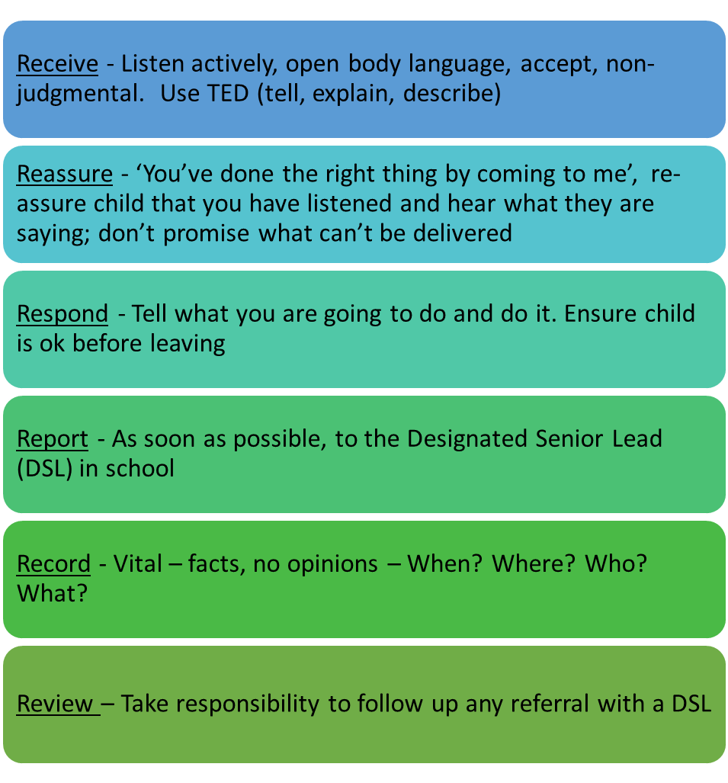
Dealing with a Disclosure made by a Child – Advice for All Members of Staff
If a child discloses that he or she has been abused in some way, the member of staff or volunteer should follow this guidance:

In addition staff must:
- Inform the Designated Safeguarding Lead without delay and follow safeguarding process.
- Complete the Safeguarding incident/welfare concern form and pass it to the DSL.

Staff will reassure victims that they are being taken seriously and that they will be supported and kept safe. Staff are also clear that the victim should never be given the impression that they are creating a problem by reporting abuse, sexual violence or sexual harassment. Nor should a victim ever be made to feel ashamed for making a report. Dealing with a disclosure from a child and safeguarding issues can be stressful. Consider seeking support for yourself and discuss this with the DSL. Further information about what to do if staff are worried that a child is being abused is available here in advice for practitioners: https://www.gov.uk/government/publications/what-to-do-if-youre-worried-a-child-is-being-abused--2

Making a Referral: If a child or young person is at risk of harm, abuse or neglect please report it to the Integrated Front Door:
- Mon-Fri, 9:00am – 5.00pm Tel: 0151 606 2008
- Outside of these hours Tel: 0151 677 6557
- Email: IFD@wirral.gov.uk
In an emergency always call police on 999.
If you think there has been a crime but it is not an emergency call 101.

The new online Request for Services referral form can be accessed here:
https://wirral-self.achieveservice.com/service/Children_and_families_request_for_support_form

In borderline cases, where there is room for doubt as to whether a referral should be made, the DSL will consult with the LADO on a no names basis without identifying the family. However, as soon as sufficient concern exists that a pupil may be at risk of significant harm, a referral to MASH will be made without delay. The school will not investigate allegations without first gaining the agreement of the LADO. In the case of serious harm, the Police will be informed from the outset. Discussions will be recorded in writing, with any communication with both the individual and the parents of the child/children agreed. The LIFE School will make every effort to maintain confidentiality and guard against publicity if there are allegations against staff up to the point where the accused person is charged with an offence. The following definitions will be used when determining the outcome of all allegation investigations:
• Substantiated: there is sufficient evidence to prove the allegation;
• Malicious: there is sufficient evidence to disprove the allegation and there has been a deliberate act to deceive;
• False: there is sufficient evidence to disprove the allegation;
• Unsubstantiated: there is insufficient evidence to either prove or disprove the allegation. The term, therefore, does not imply guilt or innocence;
• Unfounded: to reflect cases where there is no evidence or proper basis which supports the allegation being made.

Unsubstantiated, false or malicious allegations: If a report is determined to be unsubstantiated, unfounded, false or malicious, the Designated Safeguarding Lead will consider whether the child and/or the person who has made the allegation needs help or may have been abused by someone else and this is a cry for help. In such circumstances, a referral to children’s social care may be appropriate. Where an allegation by a pupil is proven to have been deliberately invented or malicious, the Headteacher will consider whether to take disciplinary action in accordance with the school’s Behaviour and Sanctions Policy. Where a parent has made deliberately invented or malicious allegations, the Headteacher will consider whether to terminate the pupil’s placement at the school on the basis that they have treated the school or a member of staff unreasonably, unless a working relationship based on trust, respect and transparency is established moving forward. The LIFE School reserve the right to contact the MASH to determine the appropriate action. We have a duty of care towards our employees by ensuring that effective support is provided for anyone facing an allegation through the school’s Human Resources (HR)/Personnel arrangements.

Low-Level Concerns (please also see our Staff Code of Conduct Policy): ): The school aims to create a culture of openness, trust and transparency in which the school’s or college’s values and expected behaviour are constantly lived, monitored and reinforced by all staff. A low-level concern is defined as when a member of staff may have acted in a way that is inconsistent with the Staff Code of Conduct, including inappropriate conduct outside of work and does not meet the allegations threshold or is otherwise not considered serious enough to consider a referral to the LADO. Examples of such behaviour could include, but are not limited to:
- being over friendly with children;
- having favourites;
- taking photographs of children on their mobile phone;
- engaging with a child on a one-to-one basis in a secluded area or behind a closed door; or,
- using inappropriate sexualised, intimidating or offensive language.

All low-level concerns about a member of staff should be reported to the Headteacher or DSL in their absence. If the concern related to a person employed by a supply agency, that concern should be recorded, shared with the Headteacher and also the supply agency or employer. Records of Low-level concerns will be recorded in writing, in the same manner as allegations that meet the harms threshold to ensure that any patterns in behaviour are identified and a course of action decided upon.

Record Keeping: As part of meeting a pupil’s needs we recognise we have clear powers to share, hold and use information between our professionals and local agencies. All concerns, discussions and decisions made and the reasons for those decisions must be recorded in writing (signed and dated). Supporting Families, Enhancing Future model (SFEF) to be used to capture the child’s voice and their daily lived experience. We will continue to support any pupil leaving the school about whom there have been concerns by ensuring that all appropriate information, including Safeguarding and welfare concerns, is forwarded under confidential cover to the pupil’s new school as a matter of priority. Schools should have at least two emergency contacts for every child in the school in case of emergencies, and in case there are welfare concerns at the home in order to reduce the risk of not making contact with family members where welfare and/or safeguarding concerns are identified. Fears about sharing information will not be allowed to stand in the way of the need to safeguard and promote the welfare of children. Records will include:
- a clear and comprehensive summary of the concern;
- details of how the concern was followed up and resolved;
- a note of any action taken, decisions reached and the outcome.

Discussing Concerns with the Family and the Child – DSL: In general, the DSL will always discuss any concerns the school may have with the child’s parents. They need to know that the school has concerns about their child. However, the DSL will not discuss concerns if they believe that this would place the child at greater risk or lead to loss of evidence for a police investigation. If DSL makes a decision not to discuss concerns with the child’s parents or carers, this must be recorded in the child’s Safeguarding file with a full explanation for the decision. It is important to record and consider the child’s wishes and feelings, as part of planning what action to take in relation to concerns about their welfare. Capturing the lived experience of the child is paramount to ensure that actions remain child-centered (See Appendix C (Supporting Families Enhancing Futures - SFEF) model to capture the child’s lived experience.

When talking to children, the DSL take account their age, understanding and preferred language, which may not be English. It is also important to consider how a SEND child may need support in communicating. How a child is spoken to will also depend on the substance and seriousness of the concerns. Staff may need to seek advice from the Integrated Front Door or the police to ensure that neither the safety of the child nor any subsequent investigation is jeopardised. If concerns have arisen as a result of information given by a child, it is important to reassure the child but not to promise confidentiality.

The DSL will discuss concerns with the parents and seek their agreement to making a referral to the Integrated Front Door, unless it is considered that this would place the child at increased risk of significant harm.

Staff do not need the parents’ consent to make a referral if they consider the child is in need of protection, although parents will ultimately be made aware of which organisation made the referral. If parents refuse to give consent to a referral but the DSL decides to continue, this will be made clear to the Integrated Front Door (0151 606 2008). If the DSL decide to refer the child without the parents’ consent, this will be recorded with a full explanation of the decision. When staff make a referral, they should agree with the Integrated Front Door what the child and parents will be told, by whom and when.

Safeguarding Policy:

Introduction: Safeguarding children is everyone’s responsibility. Everyone who comes into contact with children and families has a role to play ensuring children and young people are safe from abuse, exploitation and harm. Our school is committed to safeguarding children and aims to create a culture of vigilance.

Our pupils’ welfare is our paramount concern. The CEO and the Advisory Board will ensure that our school will safeguard and promote the welfare of pupils and work together with agencies to ensure that our school has adequate arrangements to identify, assess and support those children who are suffering or likely to suffer harm.

Our school is a community and all those directly connected, staff members, advisors, parents, families and pupils, have an essential role to play in making it safe and secure for all.

This procedure document provides the basis for good practice within the school for Safeguarding work. It should be read in conjunction with the Wirral Safeguarding Partnership safeguarding Policies and Procedures. These are in keeping with relevant national procedures and reflect what the partnership considers to be safe and professional practice in this context.

Our Ethos: We believe that this school should provide a caring, positive, safe and stimulating environment that promotes the social, physical, spiritual and moral development of the individual child; enabling all children to thrive. We recognise the importance of providing an environment within our school that will help children feel safe and respected. We recognise the importance of enabling children to talk openly and to feel confident that they will be listened to. We recognise that both mental and physical health are relevant to safeguarding and the welfare of children. We recognise that all adults within the school, including permanent, supply staff, temporary staff, volunteers, parents and the Proprietor, have a full and active part to play in protecting our pupils from harm. We will work with parents to build a solid understanding of the school’s responsibilities to ensure the welfare of all children, including the need for referrals to other agencies in some situations.

Scope: In line with the law, this policy defines a child as anyone under the age of 18 years but in the case of SEN it is up to 25 years of age. This policy applies to all members of staff in our school, including all permanent, temporary and support staff, the Proprietor, volunteers, contractors and external service or activity providers. This policy applies to all learners in this school.

The Legal Framework: Section 175 of the Education Act 2002 places a duty on governing bodies of maintained schools and further education institutions (including sixth-form colleges) to make arrangements for ensuring that their functions relating to the conduct of the school are exercised with a view to safeguarding and promoting the welfare of children who are pupils at the school. Section 157 of the same Act places a similar duty on non-maintained and independent schools, including free schools and academies.

Under section 10 of the Children Act 2004, all maintained schools, further education colleges and independent schools, including free schools and academies, are required to co-operate with the local authority to improve the well-being of children in the local authority area.

Under section 14B of the Children Act 2004, the Local Safeguarding Children Partnership can require a school or further education institution to supply information in order to perform its functions. This must be complied with.
This policy and the accompanying procedure have been developed in accordance with the following statutory guidance and local safeguarding procedures:

Working Together to Safeguard Children: A Guide to Inter-Agency Working to Safeguard and Promote the Welfare of Children: (2018) https://www.gov.uk/government/publications/working-together-to-safeguard-children--2

Keeping Children Safe in Education: Statutory Guidance for Schools and Colleges, Updated September 2022: https://www.gov.uk/government/publications/keeping-children-safe-in-education--2

Relationships, Sex and Health Education (DfE: currently in force )

Prevent Duty Guidance: for England and Wales (currently in force) (Prevent). Prevent is supplemented by non-statutory advice and a briefing note:

All procedures can be found on the Wirral Safeguarding Children Partnership website: https://www.wirralsafeguarding.co.uk/procedures/

Roles and Responsibilities: The school’s Designated Safeguarding Lead (DSL) with overall designated responsibility for safeguarding is Alastair Saverimutto, CEO. We have a deputy Designated Safeguarding Lead – Mrs Sarah Quilty (Headteacher) to ensure there is appropriate cover for this role at all times. The responsibilities of all Designated Safeguarding Lead are described in Appendix A.

The Designated Safeguarding Lead will be on our school’s leadership team and their role of Designated Safeguarding Lead will be explicit in their job description. This person should have the appropriate authority and be given the time, funding, training, resources and support to provide advice and support to other staff on child welfare and Safeguarding matters, to take part in strategy discussions and inter-agency meetings – and/or to support other staff to do so – and to contribute to the assessment of children. The designated safeguarding lead (and any deputies) are most likely to have a complete safeguarding picture and be the most appropriate person to advise on the response to safeguarding concerns. (KCSIE, 2022).

The school has a nominated Advisory Board Member , responsible for safeguarding to champion good practice, to liaise with the head teacher and to provide information and reports to the governing body. The case manager for dealing with allegations of abuse made against school staff members is the Headteacher. The case manager for dealing with allegations against the Headteacher is the Chief Executive Officer (Mr. Alastair Saverimutto).

The Headteacher will ensure that the policies and procedures adopted by the Chief Executive Officer are fully implemented and sufficient resources and time are allocated to enable staff members to discharge their safeguarding responsibilities. The Advisory Board are collectively responsible for ensuring that safeguarding arrangements are fully embedded within the school’s ethos and reflected in the school’s day-to-day practice.

We ensure all staff, Advisory Board Members, the Chief Executive Officer, volunteers and external providers know how to recognise signs and symptoms of abuse, how to respond to pupils who disclose abuse and what to do if they are concerned about a child. They are aware that behaviours and physical signs linked to behaviours that put children in danger. All staff should know what to do if a child tells them he/she is being abused or neglected. Staff should know how to manage the requirement to maintain an appropriate level of confidentiality. This means only involving those who need to be involved, such as the designated safeguarding lead (or a deputy) and children’s social care. Staff should never promise a child that they will not tell anyone about a report of abuse, as this may ultimately not be in the best interests of the child.

Thresholds for Intervention: If staff have any concerns about a child’s welfare, they should act on them immediately, following the procedures set out our supporting Procedures document. We follow the local criteria for action alongside the local protocol for safeguarding assessments. Please see Appendix 4 which sets out the process our staff will go through if they have concerns about a child. Options will then include:
• managing any support for the child internally via the school or school’s own pastoral support processes;
• an early help assessment; or a referral for statutory services (for example as the child might be in need, is in need or suffering or likely to suffer harm).

Early Help: In the first instance staff should discuss early help requirements with our DSL. The DSL will lead on liaising with other agencies and in setting up an inter-agency assessment as appropriate. Early Help in our school allows pupils to be supported at any point in their life by a range of external support agencies enabling potential concerns to be addressed, to prevent further problems arising or before a child may come into immediate danger. Targeted early help services, arranged by the local authority, address the assessed needs of a child and their family as a result of an Early Help Assessment Form coming under the term “Team around the Child” (TAC). This form would normally be completed by the DSL acting as the Lead Professional or another Educational agency. Our staff are, in particular, alert to the potential need for early help for a child who is not making age appropriate progress and needs support from more than one additional agency to meet the child‘s needs, or health or emotional difficulties are impacting the pupil’s progress and/or wellbeing. Our staff recognise their role in the early help process and are, in particular, alert to the potential need for early help for a child who:
  - is disabled or has certain health conditions and has specific additional needs;
  - has special educational needs (whether or not they have a statutory Education, Health and Care Plan);
  - has a mental health need; is a young carer;
  - is showing signs of being drawn in to anti-social or criminal behaviour, including gang involvement and association with organised crime groups or county lines;
  - is frequently missing/goes missing from care or from home;
  - is at risk of modern slavery, trafficking, sexual or criminal exploitation; is at risk of being radicalised or exploited;
  - has a family member in prison, or is affected by parental offending;
  - is in a family circumstance presenting challenges for the child, such as drug and alcohol misuse, adult mental health issues and domestic abuse; is misusing drugs or alcohol themselves;
  - has returned home to their family from care and/or is showing early signs of abuse and/or neglect;
  - is at risk of honour-based abuse such as Female Genital Mutilation or Forced Marriage;
  - is a privately fostered child and
  - is persistently absent from education

After gaining consent from the child/family to share information gathered from discussions, relevant professionals will be invited to come together in a ‘Team around the Family’ (TAF) to assess the child’s needs and decide with the child/family a course of action to provide the services needed. A TAC is a multi-disciplinary team of practitioners established on a case-by-case basis to support a child and their family.

If the allegation threshold is NOT met, the LA Designated Officer will agree with you an appropriate response (E.g. for the agency to undertake further enquiries or undertake an internal investigation).

If the allegation threshold is met a strategy meeting will normally be held either by phone or in person. Normally a senior manager / safeguarding lead, the LA Designated Officer, HR, Police and social care are invited to attend. Relevant information is shared, risks to children are considered and appropriate action agreed – e.g. child protection and other enquiries, disciplinary measures or criminal proceedings. A record of the meeting will be made, and regular reviews will take place until a conclusion is reached. After gaining consent from the child/family to share information gathered from discussions, relevant professionals will be invited to come together to assess the child’s needs and decided with the child/family a course of action to provide the services needed. This is a multi-disciplinary team of practitioners established on a case-by-case basis to support a child and their family.

Child in Need - S17 of the Children Act 1989: A ‘Child in Need’ referral should be considered where the needs of the child are unlikely to be met under an EHA, such as a child with complex disabilities, when a social work led assessment is required. Section 17 of the Children Act says that an assessment for services should be undertaken by the Local Authority if: Child(ren) are unlikely to achieve or maintain, or to have opportunity to achieve or maintain a reasonable standard of health or development, without the provision of services by a local authority. Their health or development is likely to be impaired, or further impaired without the provision of such services. They are disabled. This could include children who self-harm or disclose an intent to commit suicide.

Child Protection (S47 Children Act 1989): The Local Authority has a statutory duty to investigate when there is reasonable cause to suspect that a child is suffering, or is likely to suffer, significant harm due to the actions or inactions of others. It is not possible to rely on one absolute criterion when judging what constitutes significant harm. Consideration of the severity of ill-treatment may include the extent of the harm suffered, the context within which it occurred and its duration. In order to understand and evidence ‘significant harm’, it is necessary to consider the family context, together with the child’s development within their wider social and cultural environment. Significant harm may also arise from a combination of significant events, which are both acute and long standing and which may impair the child’s physical, psychological and social development. If staff or volunteers have significant concerns about any child they should make them known to the DSL. A referral to children’s social care will be made immediately if there is risk of immediate harm to a child and, if a crime may have been committed, the matter will be reported to the police. It is important to understand that anyone can make a referral.

Working with our Safeguarding Partners: The LIFE Wirral Sports School will work with children’s social care, the police, health services and other services to promote the welfare of children and protect them from harm. This includes providing a coordinated offer of early help when additional needs of children are identified and will contribute to inter-agency plans to provide additional support to children subject to child protection plans. We allow access for children’s social care from the host local authority and, where appropriate, from a placing local authority, for that authority to conduct, or to consider whether to conduct, a section 12 or a section 47 assessment.
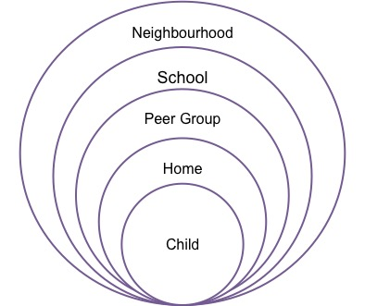
Contextual Safeguarding: We recognise that young people’s behaviours, levels of vulnerability and levels of resilience are all informed by the social/public, as well as private, contexts in which young people spend their time. When spending time in these extra-familial contexts young people may be exposed to healthy norms which promote pro-social relationships, or they may encounter harmful norms that are conducive to abusive and exploitative relationships.

As a result, we identify, assess and intervene where possible in all of the social environments where abuse and exploitation of young people can occur – in essence to take a ‘contextual’ approach to safeguarding. For example, our school leadership works with professionals and pupil body to challenge harmful, gendered school cultures, thus improving the pre-existing school environment. Additionally, we help to promote a culture of safety with the curriculum and around the school regarding pupils’ online activities – a place where young people spend an increasing amount of time, raising their vulnerability to potential abuse. We will provide as much contextual information as possible to Children’s Social Care, when a referral is made.

Serious Violent Crime and Serious Violence: Our staff are aware of the indicators, which may signal that children are at risk from, or are involved with serious violent crime. These may include increased absence from school, a change in friendships or relationships with older individuals or groups, a significant decline in performance, signs of self-harm or a significant change in wellbeing, or signs of assault or unexplained injuries. Unexplained gifts or new possessions could also indicate that children have been approached by, or are involved with, individuals associated with criminal networks or gangs and may be at risk of criminal exploitation. All staff are made aware of the range of risk factors which increase the likelihood of involvement in serious violence, such as being male, having been frequently absent or permanently excluded from school, having experienced child maltreatment and having been involved in offending, such as theft or robbery. If staff suspect that a pupil is at risk of serious violence, this will be reported to the DSL immediately. Please see the Home Office Guidance, which the school follows, on Preventing youth violence and gang involvement.

Concerns and allegations of abuse made against other children (Peer on Peer Abuse inclusive of sexual violence or harassment and banter) – Please see our Peer-on-Peer Abuse, including Sexual Violence and Sexual Harassment Policy for more details including the latest DfE Guidance (Sexual Violence and Sexual Harassment between children in schools and colleges (DfE: September 2022)): We recognise that some pupils on occasion will negatively affect the learning and wellbeing of others and their behaviour will be dealt with under the school’s Anti-Bullying (including Cyber-bullying) and Behaviour Management Policies. Staff are clear as to our policy and whole-school approach with regards to peer-on-peer abuse whether inside or outside school or online and are trained to manage a report of child-on-child sexual violence and sexual harassment. The school understands that though we may have few or even no reported cases of peer-on-peer abuse, such abuse may still be taking play and simply not being reported.

We recognise the gendered nature of peer-on-peer abuse (i.e. that it is more likely that girls will be victims and boys’ perpetrators), but that all peer-on-peer abuse is unacceptable and will be taken seriously. We have a zero-tolerance approach to abuse and that it should never be tolerated or dismissed as ‘just banter’, ‘just having a laugh’, ‘part of growing up’ or ‘boys being boys’ and downplaying certain behaviours can lead to a culture of unacceptable behaviours, an unsafe environment for children and in worst case scenarios a culture that normalises abuse leading to children accepting it as normal and not coming forward to report it. Peer on peer abuse can take many forms, including:
- bullying (including cyberbullying, prejudice-based and discriminatory bullying);
- abuse in intimate personal relationships between peers;
- physical abuse such as hitting, kicking, shaking, biting, hair pulling, or otherwise causing physical harm (this may include an online element which facilitates, threatens and/or encourages physical abuse);
- sexual violence, such as rape, assault by penetration and sexual assault;(this may include an online element which facilitates, threatens and/or encourages sexual violence);
- sexual harassment, such as sexual comments, remarks, jokes and online sexual harassment, which may be standalone or part of a broader pattern of abuse;
- causing someone to engage in sexual activity without consent, such as forcing someone to strip, touch themselves sexually, or to engage in sexual activity with a third party;
- consensual and non-consensual sharing of nudes and semi nudes images and or videos (also known as sexting or youth produced sexual imagery);
- upskirting, which typically involves taking a picture under a person’s clothing without their permission, with the intention of viewing their genitals or buttocks to obtain sexual gratification, or cause the victim humiliation, distress or alarm; and
- initiation/hazing type violence and rituals (this could include activities involving harassment, abuse or humiliation used as a way of initiating a person into a group and may also include an online element).

When dealing with abuse by young people on peers, we follow the key safeguarding documents, Keeping Children Safe in Education (DfE: September 2022) and Working Together to Safeguard Children (HM Govt: July 2018), even where an alleged perpetrator(s)(s) is a child and we adhere to the Human Rights Act and the Equality Act. Additionally, we use a Peer-on-Peer Abuse toolkit to support staff in their safeguarding of our students. Sexualised abuse, including verbal abuse by peers is a safeguarding issue and is included in the college’s broader approach to safeguarding. If the college received an allegation of abuse by one or more pupils but is alleged to have taken place outside of the college premises, our safeguarding principles remain the same, and we could still carry out a referral to children’s services as necessary.

However, where there is ‘reasonable cause to suspect that a pupil is suffering, or likely to suffer significant harm’ the concern or allegation of Peer-on-Peer abuse must be reported to the DSL immediately, who will then refer to the MASH to discuss the case. A factual record should be made of the concern or allegation, but no attempt at this stage should be made to investigate the circumstances. A copy of the discussions and outcomes will be kept in both pupils’ files. Additionally, if appropriate the DSL will also refer pupils to an external safeguarding agency such as Childline and NSPCC. This will entail:
- effective implementation of our school’s usual safeguarding and anti-bullying policies (and recognition that sexualised abuse, including verbal abuse, by peers is a potential safeguarding issue;
- seeking advice from statutory agencies, as appropriate, and readiness to make a referral if an incident meets the referral threshold set by the local Safeguarding Children Partnership;
- if a child is in immediate danger or is at risk of harm, an immediate referral to children’s social care and/or the police;
- following the advice for practitioners in: What to do if you’re worried a child is being abused;
- effective information sharing with any agencies or other professionals involved;
- where allegations of abuse or assault have been made against one or more of our pupils, a thorough risk-assessment of the situation and risk-based decision-making (with the benefit of the advice of statutory authorities, where appropriate) should be carried out with a view to ensuring the safety of all pupils and that both alleged victims and perpetrator(s) pupils receive appropriate support.
- decisions arising that might include, for example, whether the accused pupil should be removed from our school for a period of time, or from certain classes; whether contact with certain individuals should be prevented or supervised,
- the availability of counselling, the adequacy of arrangements for listening to children etc;
- good record keeping of related conversations, meetings and communications.

Minimising the risk of peer-on-peer abuse: The LIFE Wirral Sports School, recognises the wide variety of pupils’ backgrounds and cultures who attend the school and as such, the requirement for us to promote pupils to respect, tolerate and show good will toward each other. We have employed a number of procedures to help minimise the risk of peer on peer abuse, with the majority of these focusing on educating our pupils about what is and what is not appropriate with regards to all forms of relationships with their peers. As part of our PSHEE and Relationship and Sex Education (RSE) lessons, we promote healthy and respectful peer- to-peer communications and behaviours between or pupils and provide an environment, which challenges inappropriate behaviour. We teach our pupils to look out for potential signs that there may be an imbalance in power or control, the importance of permission-seeking and giving in relationships with friends, peers and adults and what to do to seek support. We make it explicit to our pupils what constitutes sexual harassment and sexual violence and why these are always unacceptable. We also teach out pupils about different types of bullying (including cyberbullying), the impact of bullying, responsibilities of bystanders (primarily reporting bullying to an adult) and how to get help.

Sexual Violence and Sexual Harassment between children: At LIFE Wirral Sports School, we take our definition of sexual violence from the Sexual Offences Act 2003, which considers rape, assault by penetration and sexual assault, all types of sexual violence. The school recognises that sexual violence can happen both inside and outside of school which can occur online and offline. In addition, we define sexual violence as ‘unwanted conduct of a sexual nature’ that can occur online and offline. Sexual violence and sexual harassment can be between two children, or a group of children of any age and sex. Both sexes may be affected, although girls are more likely to be victims of sexual violence, and boys are more likely to be perpetrator(s)s of sexual harassment. Sexual violence and sexual harassment exist on a continuum and may overlap; they can occur online and face to face (both physically and verbally) and are never acceptable. We recognise that Children with SEND are likely to be more vulnerable. LIFE Wirral Sports School is aware that online sexual violence or sexual harassment can be more complex, such as images shared at another school or across the internet, or the victim being excluded offline as well as online. Sexual harassment is likely to: violate a child’s dignity, and/or make them feel intimidated, degraded or humiliated and/or create a hostile, offensive or sexualised environment. We recognise that sexual violence and harassment can occur both online and offline, both physically and verbally and is never acceptable. We make it clear that all forms of sexual violence and harassment are unacceptable and will not be tolerated. Whilst not intended to be an exhaustive list, sexual harassment can include:
  - sexual comments, such as: telling sexual stories, making lewd comments, making sexual remarks about clothes and appearance and calling someone sexualised names;
  - sexual “jokes” or taunting;
  - upskirting;
  - physical behaviour, such as: deliberately brushing against someone, interfering with someone’s clothes (this may cross a line into sexual violence) and displaying pictures, photos or drawings of a sexual nature; and
- online sexual harassment, which might include: non-consensual sharing of nude and semi-nudes images and or videos (both often referred to as sexting); inappropriate sexual comments on social media; exploitation; coercion and threats. Online sexual harassment may be standalone, or part of a wider pattern of sexual harassment and/or sexual violence.

Responding to reports of sexual violence and sexual harassment: Sexual harassment (as set out above) creates an atmosphere that, if not challenged, can normalise inappropriate behaviours and provide an environment that may lead to sexual violence. We recognise that children may not find it easy to tell staff about their abuse verbally and that staff may be informed by a third party of through behaviour indicators of the victim. We understand the importance of the school’s role in acting upon any concerns immediately and making sure all victims are reassured and that they are being taken seriously, regardless of how long it has taken them to come forward. Though it may not be necessary to report one-off issues of sexual harassment to the police, each allegation of abuse will be taken seriously, and the Designated Safeguarding Lead will still refer these allegations to children’s social care, who will support the school in deciding whether the victim or alleged perpetrator(s) are in need of protection or other services. However, all allegations of sexual violence will be reported to the police, in parallel with children’s social care. Though children’s sexual behaviours can be developmentally expected, some more harmful sexual behaviours may cause developmental damage. The Brook sexual behaviours traffic light tool is used to help us consider harmful sexual behaviours.

Reports of sexual violence are often complex and require difficult decisions to be made, on a case-by-case basis, with the DSL taking the lead role, supported by external agencies such as children’s social care or the police. Some situations are statutorily clear: a child under the age of 13 can never consent to sexual activity (the age of consent is 16); sexual intercourse without consent is rape (as defined in law); creating or sharing sexual images or videos of under 18s is illegal, including children making or sharing these themselves.

Actions following a report of sexual violence and/or sexual harassment: A factual record should be made of the concern or allegation, taking the victim seriously, but no attempt at this stage should be made to investigate the circumstances, unless a child is in immediate danger or is at risk of harm, in which case, an immediate referral will be made to children’s social care and/or the Police. Every report will be considered on a case-by-case basis. Additionally, in cases where there is a report of rape, assault by penetration or sexual assault this should be passed to the Police. Victims will never be given the impression that they are creating a problem by reporting sexual violence or sexual harassment; they will not be made to feel ashamed for making a disclosure. The DSL will follow the advice for practitioners in: What to do if you’re worried a child is being abused and will follow through the outcomes of the discussion and if so advised by Children’s Social Care, will make a formal referral if the incident meets the referral threshold set by the Wirral Safeguarding Children Partnership, ensuring effective information sharing with any agencies or other professionals involved. The DSL will ensure good record keeping of related conversations, meeting and communications with a copy of the discussions, and outcomes will be kept securely. Staff should not assume that someone else is dealing with the incident and should discuss concerns with the DSL. Where an incident between two pupils takes place away from the school, the school’s duties and procedures remain the same.

School Staff are trained as per Part One of KCSIE on how to manage a disclosure and are aware of anonymity in cases where an allegation is progressing through the criminal justice system. LIFE Wirral Sports School will do all they reasonably can to protect the anonymity of any children involved in any report of sexual violence or sexual harassment, including considering the impact of social media. The DSL will make an immediate written risk and needs assessment where there has been a report of sexual violence, considering the victim, alleged perpetrator(s) and other children and staff at the school (including actions to protect them). Where there has been a report of sexual harassment, the need for a risk assessment should be considered on a case-by-case basis.

Risk assessments will be kept under review. In cases of sexual violence a professional risk assessment by external specialists may be required, and should be used to inform the school’s own risk assessment. LIFE Wirral Sports School will consider carefully any report or sexual violence or harassment and act in the best interests of the child. The LIFE Wirral Sports School will also consider carefully when to inform the alleged perpetrator(s), and this may be discussed with relevant agencies. The school actively considers the risks posed to our pupils and ensures adequate measures are in place to protect pupils and keep them safe. Staff may be expected to participate in any early help assessment, child protection enquiry, strategy discussion or other outcome, following a referral.

With any report of sexual violence and/or harassment, the DSL will consider:
• the wishes of the victim in terms of how they want to proceed. Victims will be given as much control as is reasonably possible over decisions regarding how any investigation will be progressed and any support that they will be offered;
• the nature of the alleged incident(s), including: whether a crime may have been committed and consideration of harmful sexual behaviour;
• the ages of the children involved, the developmental stages of the children involved;
• any power imbalance between the children, including age gaps or differences in maturity, cognition or understanding (including SEND or learning difficulties);
• if the alleged incident is a one-off or a sustained pattern of abuse;
- that sexual violence and sexual harassment can take place within intimate personal relationships between peers;
• are there ongoing risks to the victim, other children, adult pupils or school staff
• other related issues and wider context.

Managing the report: Whatever the school’s response, it is underpinned by the principle that sexual violence and sexual harassment is never acceptable and will not be tolerated. All concerns, discussions, decisions and reasons for decisions will be recorded. Dependent on the disclosure of sexual violence or sexual harassment, the school will consider the following courses of action:
- Managing internally: in some cases of sexual harassment (such as one-off incidents) the school may manage the incident internally, without the involvement of early help, following our behaviour management policy;
- Involve Early help: when a report may not require the use of statutory intervention, involving early help is particularly useful in addressing non-violent, harmful sexual behaviour and may prevent escalation;
- Referral to children’s social care: in cases where there has been harm, is at risk of harm, or there is an immediate danger, a referral will be made to children’s social care. Parents or carers will generally be informed of this, unless there is a clear reason not to at this stage. A risk and needs assessment will also be produced at this stage;
- Reporting to the Police: in cases where rape, assault by penetration or sexual assault is reported. LIFE Wirral Sports School will not wait for the outcome of a Police investigation before protecting the victim, perpetrator(s) and other children in the school. The DSL will work closely with the Police to ensure that the school’s actions do not jeopardise the Police investigation. If a child is convicted or cautioned, the school will update the risk assessment and consider suitable action through their behaviour policy.

It is important for LIFE Wirral Sports School to ensure the victim and perpetrator(s) remain protected, especially from bullying or harassment. Where no further action is taken, or a child found not guilty, school will continue to support the victim and perpetrator(s).

This is how victims of peer on peer abuse will be supported: All pupils involved, whether perpetrator(s) or victim, are treated as being ‘at risk’; a thorough risk-assessment and risk-based decision-making (with the benefit of the advice of statutory authorities, where appropriate) will be carried out with a view to ensuring the safety of all pupils and that example, whether the accused pupil should be removed from school for a period, or removal of the alleged perpetrator(s) from classes and any transport etc which is shared with the victim, whether sleeping arrangements should be changed for boarders, whether contact with certain individuals should be prevented or supervised, the availability of counselling such as referring pupils to an external safeguarding agency such as ChildLine and NSPCC and the adequacy of arrangements for listening to children etc. We recognise that any actions taken will be in the best interests of both children and is not perceived to be a judgement of guilt of the alleged perpetrator(s).

Additionally, the school:
- supports for the victim will consider their age, the nature of the allegations and the risk of further abuse; an alleged perpetrator(s) may have unmet needs themselves;
- ensures needs and wishes of the victim will be paramount, and they will be able to continue their normal routine as far as possible, so that school is a safe space for them;
- will be prepared to support a victim over a long period of time;
- The LIFE Wirral Sports School will do everything we reasonably can to protect victims from bullying or harassment as a result of any report they have made.
- Ensures that if a victim or perpetrator(s) moves to another school it is important that the new establishment is made aware of any ongoing support needs.
- must ensure the victim is safeguarded, but still provide the perpetrator(s) with an education and support as necessary.
- may discipline the alleged perpetrator(s), including while the police or social care investigation is ongoing, although they will liaise with these bodies to assist in determining any sanctions.
- will be clear about when their actions are to support the victim or perpetrator(s), and when their actions are to discipline the perpetrator(s) for their past conduct.

A pupil against whom an allegation of abuse has been made may be excluded from the school for a fixed period during the investigation and the School’s policy on behaviour, discipline and sanctions will apply. If it is necessary for a pupil to be interviewed by the police in relation to allegations of abuse, the School will ensure that, subject to the advice of Children's Social Care, the pupil's parents are informed as soon as possible and that the pupil is supported during the interview by an appropriate adult. Normally, the DSL will try to discuss any concerns about a child’s welfare with the family and where possible to seek their agreement to making a referral to MASH if necessary. However, in accordance with DfE guidance, this will only be done when this will not place the child at increased risk. The child’s views will also be considered. Where neither social services nor the police accept the complaint, a thorough school investigation should take place into the matter using the school’s usual disciplinary procedures. In situations where the school considers a safeguarding risk is present, a risk assessment will be prepared along with a preventative supervision plan. The plan should be monitored and a date set for a follow-up evaluation with everyone concerned. We draw upon the support offered by The National Organisation for the Treatment of Abusers (NOTA) to support staff training on Sexual violence and Harassment between peers.

When a pupil is in need of urgent medical attention and there is suspicion of abuse an ambulance should be called. If the response from the emergency services states that the school should take the child to hospital then the DSL, with an escort, should take the child to the Accident and Emergency Unit at the nearest hospital. They should first notify MASH and seek advice about what action the MASH or the police will take and how the parents will be informed. Normally, parents would be informed that a child requires urgent hospital attention. If the suspected abuse is sexual then the medical examination should be delayed until the MASH and the police can liaise with the hospital, unless the needs of the child are such that medical attention is the priority. There must at all times be a responsible adult with the child, whether from the school, MASH or the police, if the parents are not included. All unnecessary delays should be eradicated and inaction at any level can and should be challenged. In borderline cases, this can be done informally and without giving names in the first instance. The School will not investigate allegations without first gaining the agreement of the LADO. In the case of serious harm, the police will be informed from the outset. Discussions will be recorded in writing, with any communication with both the individual and the parents of the child/children agreed.

https://www.gov.uk/government/publications/sexual-violence-and-sexual-harassment-between-children-in-schools-and-colleges (May 2018)

Concerns should be referred to senior staff, who may need to consult with the Designated Safeguarding Lead. Victims of peer-on-peer harm should be supported by the school’s pastoral system.

Supporting Children: We recognise that children who are abused or witness violence are likely to have low self-esteem and may find it difficult to develop a sense of self-worth. They may feel helpless, humiliated and some sense of blame. Our school may be the only stable, secure and predictable element in their lives. We accept that the behaviour of a child in these circumstances may range from that which is perceived to be normal to aggressive or withdrawn. Our school will support all pupils by:
- ensuring the content of the curriculum includes social and emotional aspects of learning; Through PSHE and other curriculum contexts, pupils are encouraged to talk about feelings and deal assertively with pressures, are listened to, and know to whom they can turn to for help and advice;
- providing pupils with a range of appropriate adults to approach if they are in difficulties; and ensuring that pupils are taught about safeguarding so that they ‘recognise when they are at risk and how to get help when they need it’ (KCSIE 2022)
- supporting the child’s development in ways that will foster security, confidence and independence and encourage the development of self-esteem and self-assertiveness while not condoning aggression or bullying (See our Anti-Bullying Policy for more details);
- ensuring a comprehensive curriculum response to online safety, enabling children and parents to learn about the risks of new technologies and social media and to use these responsibly; plus Relationship and Sex Education (RSE) requirements
- liaising and working together with other support services and those agencies involved in safeguarding children;
- ensuring that the curriculum will help children stay safe, recognise when they do not feel safe and identify who they might or can talk to and will support young people to become more resilient to inappropriate behaviours towards them, risk taking behaviours and behaviours that children may be coerced into including ‘sexting’ and ‘Harmful Sexualised Behaviour’;
- having a behaviour policy that is aimed at supporting vulnerable pupils in the school. The school will ensure that each pupil knows that some behaviour is unacceptable but that they are valued and not to be blamed for any abuse which has occurred;
- ensuring repeated hate incidents, e.g. racist, homophobic or gender- or disability-based bullying, are considered under Safeguarding procedures and monitoring children who have been identified as having welfare or protection concerns and providing appropriate support;
- acknowledging the importance of ‘contextual safeguarding’, which considers wider environmental factors in a pupil’s life that may be a threat to their safety and/or welfare. (Working together to safeguard children July 2018 and KCSIE September 2022).
- liaising with a range of agencies that support the pupil such as Health Services, Wirral Social Care, Child and Adolescent Mental Health Services, Education Welfare Services, Special Educational Support Services, Youth Services and the Educational Psychology Service.
- ensuring that, when a pupil who is the subject of a Child Protection Plan leaves, their information is transferred to the new school within two weeks and that the child's Social Worker is informed that the child has moved;
- After 20 days absence if a child has moved and the new school is unknown the school will post details on the ‘Pupil to Pupil ’ register;
- alert the authority if it is aware of any child being looked after under a Private Fostering arrangement. On admission to school, and at other times, the school will be vigilant in identifying any private fostering arrangement. (See Appendix C)
- acknowledging that a child that is looked after (CLA) or has been previously looked after by the Local Authority potentially remains vulnerable and all staff should have the skills, knowledge and understanding to keep CLA and previously looked after children safe. It is important that all agencies work together and prompt action is taken on concerns to safeguard these children, who are a particularly vulnerable group;
- applying disciplinary measures such as restraint or isolation in response to incidents involving children with SEN and disabilities, by considering the risks carefully, given the additional vulnerability of the group;
- recognising that to safeguard a pupil, it may be necessary to use restraint and yet restraint is likely to impact on the well-being of the child. By planning positive and proactive behaviour support, schools and colleges can reduce the occurrence of risky behaviour and the need to use restraint. Guidance is available here:

https://www.gov.uk/government/publications/use-of-reasonable-force-in-schools

We will prevent people who pose risks to children from working in our school by ensuring that all individuals working in any capacity at our school have been subjected to safeguarding checks in line with Keeping Children Safe in Education: Statutory
Guidance for Schools and Colleges, September 2022. In addition to obtaining the DBS certificate described, anyone who is appointed to carry out teaching work will require an additional check to ensure they are not prohibited from teaching. See Appendix C. A check of any prohibition can be carried out using the Teacher Services’ system that may be found here: https://teacherservices.education.gov.uk/ (January 2018)

Prohibition orders are described in the Teaching Regulation Agency (TRA) publication: Teacher misconduct: the prohibition of teachers. It can be found here: https://www.gov.uk/government/publications/teacher-misconduct-the-prohibition-of-teachers--3

We will ensure that agencies and third parties supplying staff provide us evidence that they have made the appropriate level of safeguarding checks on individuals working in our school. See Appendix C, for information on Single Central Record (SCR).
Our single central covers the following people: all staff, including teacher trainees on salaried routes, agency and third-party and supply staff who work at the school.
- Every job description and person specification will have a clear statement about the safeguarding responsibilities of the post holder.
- We will ensure that at least one member of every interview panel has completed safer recruitment training within the last 5 years.
- We have a procedure in place to manage allegations against members of staff, supply staff and volunteers in line with WSCP procedures.

Supply teachers: We will consider all allegations against an individual not directly employed by, where disciplinary procedures do not fully apply, (for example, supply teachers provided by an employment agency) and ensure allegations are dealt with properly, including contacting the agency from whom the supply staff work for. There is an agreed staff behaviour policy (sometimes called the code of conduct) which is compliant with ‘Safer Working Practices’, and includes - acceptable use of technologies, staff/pupil relationships and communications including the use of social media. For agency and third-party supply staff, schools and colleges must also include whether written confirmation has been received that the employment business supplying the member of supply staff has carried out the relevant checks and obtained the appropriate certificates, and the date that confirmation was received and whether any enhanced DBS certificate check has been provided in respect of the member of staff.

Guidance can be accessed: http://www.rrrecruitment.com/wp-content/uploads/2016/04/Guidance-for-Safer-Working-Practice-October-2015.pdf

Safeguarding arrangements during mandatory school closures / remote working (such as COVID-19): The LIFE SCHOOL considers safeguarding of critical importance at a time when our school is required to close and will do all it can to continue to protect its pupils and staff, especially those who are vulnerable. This includes arrangements for online/remote learning spaces and the monitoring of attendance to those lessons. Whilst additional arrangements have been established, all the school’s policies, rules and guidelines remain in place and adherence to all statutory guidance is expected. We will incorporate any updated advice from the LA about local arrangements, including changes to contact details or referral thresholds etc. Additional detail regarding the behaviour and conduct of both staff and pupils, including our arrangements for remote learning and 1:1 meetings can be found in our Safeguarding Arrangements for Remote Working Policy. Keeping Children Safe in Education (KCSIE) remains in force throughout the response to coronavirus (COVID-19). The department has guidance on the opening of schools. This guidance supports governing bodies, proprietors, senior leadership teams and designated safeguarding leads to continue to have appropriate regard to KCSIE and keep their children safe. It suggests where schools and colleges might consider safeguarding policy and process differently when compared to business as usual.

School Closure/Remote Working Risk Assessment: As part of our additional safeguarding arrangements, we have developed a ‘School Closure/Remote Working’ risk assessment, which identifies and addresses the risks associated with pupils being required to stay at home. The mitigation measures devised by this risk assessment will enable the school to ensure we can, as effectively as possible, safeguard pupils who are not physically at the school. Although not an exhaustive list, below are some specific examples of how staff will safeguard pupils:

Teaching and support staff will:
- be available during their normal working hours (either full school day or part-time as specified in their contracts) to respond to email and other appropriate work software alerts.
- keep a register of attendance of video lessons and a log of work completed, feeding back concerns in attendance to the DSL
- attend any relevant meetings via telephone or video conference as requested.
- report any safeguarding or pastoral concerns as normal through our reporting procedures and follow-up with DSLs as usual.
- know which pupils/pupils are vulnerable and will ensure regular contact is made both with the families and the child’s social worker (if applicable), particularly if pupils are unable to physically attend school.

Senior Leadership Team will:
- be available during their normal working hours (either full school day or part-time as specified in their contracts) to respond to email and other appropriate work software alerts.
- establish a system to monitor safeguarding and attendance patterns and respond accordingly where there are concerns for the safety of children.
- attend/chair any relevant meetings via telephone or video conference as requested.
- inform all staff on a regular basis by email of safeguarding training or updates.
- know which pupils/pupils are vulnerable and will ensure regular contact is made both with the families and the child’s social worker (if applicable).
- Ensure that there is always a DSL / Deputy DSL available to contact throughout the year, in the event that a DSL is unwell.

Induction and On-Going Training for all staff, temporary staff, volunteers and the Headteacher and Advisory Board Members: : Our arrangements for the level and focus of role-appropriate and refresher training is in accordance with Wirral Safeguarding Children Partnership criteria, as required by KCSIE (DfE: Sept. 2022). All staff are provided with copies of key documents which they are required to understand. For staff who cannot read English, our school takes steps to ensure that they understand key information. This includes the active promotion of British values and an understanding of extremism and radicalisation and child exploitation. All our staff are made aware of the systems which supports safeguarding in our school and these are explained to them, as part of their staff induction as well as on-going training. This includes:
- the safeguarding (child protection) policy; their role in the early help process; the identity of the DSL and Deputy DSL’s and information about their roles (such as the implications for mental health and pastoral care and how to identify pupils at risk of radicalisation);
- The school’s policy and procedures for dealing with peer-on-peer abuse, including how to manage a report of child-on-child sexual violence and sexual harassment;
- The school’s safeguarding response to children who go missing from education, including being given a copy of the school’s Children Missing Education policy)
- The staff behaviour policy (Staff code of conduct) (which covers as a minimum, acceptable use of technologies, staff pupil relationships low-level concerns and communications, including via social media and whistleblowing);
- Part One of KCSIE (DfE: Sept. 2021) and ‘Annex A’ (which includes some types of abuse formerly mentioned in Part One of KCSIE) and copies of policies (such as behaviour management policy, anti-bullying policy, whistleblowing policy, children who are missing education and online safety including cyber bullying);
- Leaders and those who work directly with children will also be given Annex B of KCSIE which contains additional information about specific forms of abuse and safeguarding issues.
- The school’s pupil behaviour policy, including our measures to prevent bullying, including cyberbullying, prejudice-based and discriminatory bullying;
- Ensuring all staff are sensitised to act when any incident may be referred to as bullying, tyrannize, terrorise, intimidate, harass, etc., even if the alleged person has no history of that behaviour;
- Effective Behaviour Management, ensuring a good and safe educational environment which meets the needs of all pupils;
- Annual Child Protection (including online safety) and Prevent Duty training;
Our Advisory Board will also undergo specific awareness training at least every two years. All staff will have access to WSCP (Wirral Safeguarding Children Partnership) multi-agency safeguarding training and e-learning. The induction will be proportionate to staff members’ roles and responsibilities. All Designated Safeguarding Leads (DSLs) will undergo updated Safeguarding training every two years. Staff will also undertake Prevent awareness training.

We assist staff in understanding and undertaking their roles and responsibilities as set out in Part One of KCSIE. This includes talking new staff through the content of Part One in a level and depth appropriate and proportionate to the person and/or to the particular role for which they are being inducted. Updates and refreshers will also be given during staff meetings. The DSL monitors the outcome of staff training through post-training discussions with staff, highlighting any gaps in staff knowledge or failings on procedures. All staff undertake prevent awareness training and are able to refer pupils to the DSL for further help. Staff are informed of arrangements to listen to pupils by the use of counsellors, listeners, helplines and other systems to gain views and insight. When relevant, we would work in partnership with our local Prevent co-ordinator. When available in our local authority for our pupils’ age group, WRAP training will be provided for all staff.

Our staff receive annual online safety training (including at Induction), which looks at emerging technologies strategies to support online safety and highlighting key requirements from our Online Safety policy. Online safety training for staff is integrated, aligned and considered as part of the overarching safeguarding approach. In addition, all staff receive safeguarding and child protection updates (for example, via email, e-bulletins and staff meetings) as required but at least annually, to provide them with the relevant skills and knowledge to safeguard pupils effectively. Our Staff are also made aware of the early help process and understand their role in it. This includes identifying emerging problems, liaising with the DSL, sharing information with other professionals to support early identification and assessment and, in some cases, acting as the lead professional in undertaking an early help assessment. Staff members who miss the whole-school training will be required to undertake other relevant training to make up for it, e.g. by joining another school’s whole-school training, booking onto whole-school training mop-up sessions.

We will ensure that staff members provided by other agencies and third parties, e.g. supply teachers and contractors, have received appropriate safeguarding training commensurate with their roles before starting work. They will be given the opportunity to take part in whole-school training if it takes place during their period of work for the school. The Designated Safeguarding Lead will provide briefings to the school on any changes to safeguarding legislation and procedures and relevant learning from local and national serious case reviews. These will occur annually or more frequently when necessary. The school will maintain accurate records of staff induction and training.

https://www.wirralsafeguarding.co.uk/professionals/serious-case-reviews/

Teaching pupils how to Keep Safe (Educating pupils about safeguarding and radicalisation including the delivery of the prevent strategy): Our programme for PSHEE supports the process of helping our pupils develop an understanding of keeping safe and maintaining wellbeing as part of a broad and balanced curriculum. Within our PSHEE curriculum, we have a programme for Relationship and Sex Education (RSE) which includes issues such as:
- “sexting”, “banter”, sexual assault between young people and gender-based issues;
- healthy and respectful relationships;
  - what respectful behaviour looks like;
  - gender roles, stereotyping, equality;
  - body confidence and self-esteem;
  - prejudiced behaviour;
- that sexual violence and sexual harassment is always wrong and addressing cultures of sexual harassment;
  - keeping safe whilst online, when accessing remote learning, the dangers of Cyber-bulling and
  - information on the grooming process and how to protect themselves including online, and how to get help.

Online Safety (Please see our Online Safety Policy for more details): Staff are aware that technology is a significant component in many safeguarding and wellbeing issues. Children are at risk of abuse online as well as face to face. In many cases abuse will take place concurrently via online channels and in daily life. We have an effective whole school approach to online safety which empowers us to protect and educate our pupils and staff in their use of technology and establishes mechanisms to identify, intervene in, and escalate any concerns where appropriate. Our Online Safety Policy considers content, contact, conduct and commerce and includes our policy on mobile/smart technology. We ensure that pupils are safe from potentially harmful and inappropriate content including terrorist and extremist material when accessing the internet on school systems through appropriate levels of filtering, internet safety rules and online safety education with the curriculum in line with our Online Safety and Cyberbullying policies. However, we are careful to ensure “over blocking does not lead to unreasonable restrictions. We ensure staff are appropriately trained in on-line safety and we carefully consider how to manage mobile data (4G/5G) usage on the school premises through our behaviour management policy. Pupils understand the risks posed by adults or young people, who use the internet and social media to bully, groom, abuse or radicalise young people, especially pupils and vulnerable adults.

In planning curriculum input in relation to online safety we will ensure materials are differentiated to take account of the different ages, levels of understanding and vulnerabilities of our pupils so that all pupils are enabled to access this input effectively. We classify the issues within online safety into four areas of risk:
Content: being exposed to illegal, inappropriate or harmful content
Contact: being subjected to harmful online interaction with other users
Conduct: personal online behaviour that increases the likelihood of, or causes harm, such as the sending of explicit images or online bullying
Commerce: risks such as online gambling, inappropriate advertising, phishing and or financial scams

The Headteacher and Deputy Headteacher work together to limit children’s exposure to the above risks when using IT within the school, and also work with parents to support pupils learning from home and using IT within the home environment more generally. There is guidance below designed to help parents and carers to keep their children as safe as possible when online:

We support parents in providing links to up-to-date advice and guidance on Internet-Safety, social media and on-line radicalisation through CEOP’s www.Thinkuknow.co.uk and the Google Legends project along with:
https://www.google.co.uk/safetycenter/families/legends// + https://www.wirralsafeguarding.co.uk/online-safety-guidance-parents/

Confidentiality, Consent and Information Sharing: We recognise that all matters relating to Safeguarding are confidential. The head teacher or the Designated Safeguarding Lead will disclose any information about a pupil to other members of staff on a need-to-know basis only. All staff members must be aware that they cannot promise a child to keep key information a secret or to themselves which might compromise the child’s safety or well-being. All staff members have a professional responsibility to share information with other agencies in order to safeguard children.

All staff members who come into contact with children will be given appropriate training to understand the purpose of information sharing in order to safeguard and promote children’s welfare. We will ensure that staff members are confident about what they can and should do under the law, including how to obtain consent to share information and when information can be shared without consent.

Staff should not assume a colleague or another professional will take action and share information that might be critical in keeping children safe. They should be mindful that early information sharing is vital for effective identification, assessment and allocation of appropriate service provision. Information Sharing: Advice for Practitioners Providing Safeguarding Services to Children, Young People, Parents and Carers supports staff who have to make decisions about sharing information. This advice includes the seven golden rules for sharing information and considerations with regard to the Data Protection Act 2018 and General Data Protection Regulation (GDPR). If in any doubt about sharing information, staff should speak to the designated safeguarding lead or a deputy. Fears about sharing information must not be allowed to stand in the way of the need to promote the welfare and protect the safety of children. (KCSIE 2022)

Inter-Agency Working: We will develop and promote effective working relationships with other agencies, including agencies providing early help services to children, the police and Children’s Social Care. Early help means providing support as soon as a problem emerges at any point in a child’s life, from the foundation years through to the teenage years. For more information on Early Help click: https://www.wirralsafeguarding.co.uk/professionals/what-is-early-help/

We will ensure that relevant staff members participate in multi-agency meetings and forums, including child protection conferences and core groups, to consider individual children. We will participate in serious case reviews, other reviews and file audits as and when required to do so by the Wirral Safeguarding Children Partnership. We will ensure that we have a clear process for gathering the evidence required for reviews and audits and embed recommendations into practice and compile required actions within agreed timescales.

Notifiable Incidents: This is an incident involving the care of a child that meets any of the following criteria:
- A child has died (including cases of suspected suicide) and abuse or neglect is known or suspected;
- a looked after child has died (including cases where abuse is not known or suspected);
- a child has been seriously harmed and abuse or neglect is known or suspected or
- a child in a regulated setting or service has died (including cases where abuse is not known or suspected).

Any such incident should be reported to the Merseyside Child Death Overview Panel (CDOP), Irene Wright (CDOP Manager) - Tel: 0151 233 1151 / 0151 666 4581 Email: Irene.Wright@liverpool.gcsx.gov.uk along with the Reporting of Injuries, Diseases and Dangerous Occurrences (RIDDOR) in accordance with the regulations of 2013.

Pupils being withdrawn from School: If a pupil is withdrawn from the school, all efforts will be made to identify the school to which the pupil is being admitted; their confidential educational and pupil protection records will be sent separately. If the parent/guardian/carer fails to provide information regarding the new school, an urgent referral will be made to the Education Welfare Service (EWS), unless the School has safeguarding concerns about the child in which case it will be MASH.

Listening to the wishes of children and young people: If LIFE Wirral Sports School becomes aware of a safeguarding concern, the school will ensure the child’s wishes and feelings are taken into account when determining what action to take and what services to provide, though the school will operate with the best interests of the child at heart. We believe it is critical that our pupils have an adult who they can trust and The LIFE Wirral Sports School ensures that there are appropriate systems so pupils know who they can turn to and that staff will listen to them. These include: the School Council (Pupil Voice); Staff and therapists; Spiritual, Moral, Social and Cultural (SMSC) Curriculum and Helplines such as NSPCC and Child line (Contact numbers are at the end of this policy). LIFE Wirral Sports School actively encourages a sensitive and open ’listening’ environment in which staff and pupils may feel free to discuss general matters relating to safeguarding and to raise specific concerns. Members of staff should use the school’s whistleblowing policy should they have any concerns about the handling of safeguarding matters either in general or in specific cases.

Pupil Mental Health: (Please also refer to the school’s Mental Health Policy) LIFE Wirral Sports School takes its responsibilities towards pupils that may be experiencing mental health difficulties seriously. We provide support and can make links with therapists, psychiatrists and the NHS. The staff team being responsible for the safety and wellbeing of pupils, operate an ‘open door’ policy to encourage pupils to seek help themselves and for staff to refer any concerns so they are dealt with quickly and appropriately. We work closely with these professionals to maintain the pupil’s safety within school and adhere to any advice and guidance we are given. We want to make sure our pupils are happy, healthy and thrive and understand we all need a little help from time to time with the busy and stressful lives we have today. We ensure all staff are aware that mental health concerns are also considered as a safeguarding concern, as in some cases, it can be an indicator that a child has suffered or is at risk of suffering abuse, neglect or exploitation. Staff should pass on concerns to a DSL and follow the procedures set out in this policy. Whilst we refer pupils to trained professionals for a diagnosis of a mental health problem, our staff are well placed to observe children day-to-day and identify those whose behaviour suggests that they may be experiencing a mental health problem or be at risk of developing one.

Where children have suffered abuse and neglect, or other potentially traumatic adverse childhood experiences, we recognise this can have a lasting impact throughout childhood, adolescence and into adulthood. Staff are aware of how these children’s experiences, can impact on their mental health, behaviour and education. If staff have a mental health concern about a child that is also a safeguarding concern, our Safeguarding procedures are followed, by speaking to the DSL.

The Department for Education has published advice and guidance on Preventing and Tackling Bullying, and Mental Health and Behaviour in Schools. In addition, Public Health England has produced a range of resources to support schools in promoting positive health, wellbeing and resilience among young people including its guidance Promoting children and young people’s emotional health and wellbeing. Its resources include social media, forming positive relationships, smoking and alcohol. See Rise Above for links to all materials and lesson plans.

Pupils who are particularly vulnerable: Please also refer to our Special Educational Needs and Disabilities Policy. We recognise that some pupils are more vulnerable to abuse and neglect and that additional barriers exist when recognising abuse for some children. We understand that this increase in risk is due more to societal attitudes and assumptions or child protection procedures, which fail to acknowledge pupil’s diverse circumstances, rather than the individual child’s personality, impairment or circumstances, such as young carers or those with special educational needs or disabilities. A young carer is a person under 18 who provides or intends to provide care for another person (of any age, except generally where that care is provided for payment, pursuant to a contract or as voluntary work).

The child may be more prone to peer group isolation or bullying (including prejudice-based bullying) and disproportionately impacted by the behaviour without outwardly showing any signs that they are experiencing it. In some cases possible indicators of abuse, such as a child’s mood, behaviour or injury, might be assumed to relate to the child’s impairment or disability rather than giving a cause for concern; or a focus may be on the child’s disability, special educational needs or situation without consideration of the full picture. In other cases, such as bullying, the child may be disproportionately impacted by the behaviour without outwardly showing any signs that they are experiencing it. Some children may also find it harder to disclose abuse due to communication barriers and difficulties in managing or reporting these challenges, lack of access to a trusted adult or not being aware that what they are experiencing is abuse.

Our staff are alert to those pupils with longer-term medical conditions who are young carers or have special educational needs or disabilities. Particular vigilance will be exercised in respect of pupils who are the subjects of Child Protection Plans and any incidents or concerns involving these pupils will be reported immediately to the allocated Social Worker (and confirmed in writing). If a pupil discloses that he/she has witnessed domestic violence, or it is suspected that he/she may be living in a household which is affected by family violence, this will be referred to the DSL as a safeguarding issue. here it comes to our notice that a child under the age of 13 is, or may be, sexually active, this will result in an immediate referral to MASH and advice being given to the DSL. This will determine how and when information will be shared with parents/guardians/carers and the investigating agencies.

Safeguarding disabled pupils and pupils with medical conditions: Our staff are aware that disabled pupils experience greater risks, vulnerability and barriers to services and resources. They may have additional needs relating to physical, sensory, cognitive and/or communication impairments. Some disabled pupils may be more vulnerable to abuse because it could be assumed that indicators of possible abuse such as behaviour, mood and injury relate to the child’s disability without further exploration; they may have fewer outside contacts (isolation) than other pupils; receive intimate, personal care; have an impaired capacity to resist or avoid abuse; have communication difficulties; fear losing services or; be more vulnerable to peer abuse (e.g. bullying, sexual assault, intimidation). Our staff are alert to the medical needs of pupils including those pupils with longer term medical conditions or disabilities and offer additional pastoral support to these pupils.

Staff Behaviour Policy (Staff Code of Conduct) - Power, Positions of Trust and Staff Behaviour: Guidance is provided in The LIFE Wirral Sports School Staff Behaviour policy and Teachers’ Standards on how adults can ensure that their behaviour and actions do not place pupils or themselves at risk of harm or of allegations of harm to a pupil (for example, in one-to-one tuition, sports coaching, conveying a pupil by car, engaging in inappropriate electronic communication with a pupil, and so on). The staff Behaviour policy is wide-ranging and covers staff/pupils relationships and communications including use of social media, “breach of trust” and expands on the whistle-blowing statement in this policy. Staff must seek medical advice if they are taking medication which may affect their ability to care for children, and any staff medication must be securely stored and out of the reach of pupils at all times.

Contractors, Service and Activity Providers and Work Placement Providers: We will ensure that contractors and providers are aware of our school’s safeguarding policy and procedures. We will require that employees and volunteers provided by these organisations use our procedure to report concerns.

We will seek assurance that employees and volunteers provided by these organisations and working with our children have been subjected to the appropriate level of safeguarding check in line with Keeping Children Safe in Education: Statutory Guidance for Schools and Colleges, 2021. If assurance is not obtained, permission to work with our children or use our school premises may be refused. When we commission services from other organisations, we will ensure that compliance with our policy and procedures is a contractual requirement.

Reasons for no longer using a person’s services and reporting to the Disclosure and Barring Service (DBA) along with considering referral to the Teaching Regulation Agency (TRA). If a member of staff or volunteer tenders his or her resignation, or is dismissed and a prohibition order may be appropriate, any child protection allegations will still be followed up by the School in accordance with this policy and a referral will be made to the Disclosure and Barring Service and the TRA as soon as possible if the criteria are met. Where the school dismisses or ceases to use the services of a teacher because of serious misconduct, or might have dismissed them or ceased to use their services had they not left first, we will consider whether to refer the case to the Secretary of State (via the Teaching Regulation Agency). We also ensure that ‘Compromise Agreements’ or ‘ACAS Agreements’ never apply in such circumstances.

Whistle-Blowing and Complaints (Please see our Whistleblowing Policy for more details): We recognise that children cannot be expected to raise concerns in an environment where staff members fail to do so. Whistleblowing: guidance and code of practice for employers is located:
https://assets.publishing.service.gov.uk/government/uploads/system/uploads/attachment_data/file/415175/bis-15-200-whistleblowing-guidance-for-employers-and-code-of-practice.pdf (March 2015)

Whistleblowing Advice Line is available for all worker - 0800 028 0285 - Email help@nspcc.org.uk

We will ensure that all staff members are aware of their duty to raise concerns, where they exist, about the management of Safeguarding, which may include the attitude or actions of colleagues. If necessary, they will speak with the head teacher, the chair of the advisory board or with the Local Authority Designated Officer (LADO).

We have a clear reporting procedure for children, parents and other people to report concerns or complaints, including abusive or poor practice. We will actively seek the views of children, parents and carers and staff members on our Safeguarding arrangements through surveys, questionnaires and other means.

Site Security: All staff members have a responsibility to ensure our buildings and grounds are secure and for reporting concerns that may come to light. We check the identity of all visitors and volunteers coming into school. Visitors are expected to sign in and out in the visitors’ log and to display a visitor’s badge while on the school site. Any individual who is not known or identifiable will be challenged for clarification and reassurance. The school will not accept the behaviour of any individual, parent or anyone else, that threatens school security or leads others, child or adult, to feel unsafe. Such behaviour will be treated as a serious concern and may result in a decision to refuse the person access to the school site.

Quality Assurance: We will ensure that systems are in place to monitor the implementation of and compliance with this policy and accompanying procedures. We will complete an audit of the school’s safeguarding arrangements at frequencies specified by the Wirral Safeguarding Children Partnership and using the Section 175 online audit tool provided by them for this purpose.

More information including how to register for the audit: https://www.wirralsafeguarding.co.uk/professionals/section-11-175-audit/

Safeguarding Policy and Procedures – Appendices

These procedures, which apply to the whole school, are publicly available on the school website and upon request a copy (which can be made available in large print or other accessible format if required) may be obtained from the Designated Safeguarding Lead.

APPENDIX A – THE ROLE OF THE DESIGNATED SAFEGUARDING LEAD

Managing Referrals:
- Refer all safeguarding cases, including Early Help, to the Integrated Front Door (IFD) and to the Police if a crime may have been committed (IFD@wirral.gov.uk).
- Identify any safeguarding issues relating to individual children, especially ongoing enquiries under section 47 of the Children Act 1989.
- Act as a source of support, advice and expertise to staff members on matters of child protection and safeguarding.
- Escalate inter-agency concerns and disagreements about a child’s wellbeing. Further information can be found here: https://www.wirralsafeguarding.co.uk/procedures/10-2-multi-agency-escalation-procedure/
- Have responsibility to ensure there is at least one key adult for ‘Operation Encompass*’ and the point of contact for Child Exploitation. *Guiding principles of the scheme are here https://www.operationencompass.org/school-participation. An annual information letter to be sent to parents. All downloadable documents are here: https://www.operationencompass.org/school-participation/school-downloads.
- To ensure that the Local Authority are notified if children are persistently absent or missing from education.
- Keep staff aware of child protection procedures and ensure staff are alert to changes in children’s behaviour which could indicate that they may be in need of help or protection.

Record Keeping:
- Keep written records of Safeguarding and welfare concerns and ensure a stand-alone file is created as necessary for children with safeguarding concerns.
- Schools should have at least two emergency contacts for every child in the school in case of emergencies, and in case there are welfare concerns at the home (KCSIE 2022).
- Maintain a chronology of significant incidents for each child with safeguarding concerns.
- Ensure such records are kept confidentially and securely and separate from the child’s educational record.
- When a child leaves our school, the Designated Safeguarding Lead will make contact with the Designated Safeguarding Lead at the new school and will ensure that the safeguarding file is forwarded to the receiving school within two weeks. We will retain evidence to demonstrate how the file has been transferred; this may be in the form of a written confirmation of receipt from the receiving school and/or evidence of recorded delivery. Where a parent elects to remove their child from the school roll to home educate, the school will make arrangements to pass any safeguarding records to the Education Social Welfare Service.

Inter-Agency Working and Information Sharing:
- Co-operate and comply with Children’s Social Care for enquiries under section 47 of the Children Act 1989.
- Advocate that the Data Protection Act 2018 and GDPR do not prevent, or limit, the sharing of information for the purposes of keeping children safe; and this includes allowing practitioners to share information without consent (Keeping Children Safe in Education 2022).
- Ensure that all appropriate staff members have a working knowledge and understanding of their role in case conferences, core groups and other multi-agency planning meetings, to ensure that they attend and are able to effectively contribute when required to do so; where a report is required, this should be shared with the parents prior to the meeting.
- Liaise with other agencies working with the child, share information as appropriate and contribute to assessments.
- As required, liaise with the “case manager” (as per Part four) and the designated officer(s) at the local authority for child protection concerns (all cases which concern a staff member); and liaise with staff on matters of safety and safeguarding and when deciding whether to make a referral by liaising with relevant agencies. Act as a source of support, advice and expertise for staff.
- The school has an information sharing policy and refers to confidentiality in line with ‘Information sharing: advice for practitioners providing safeguarding services’ (DfE, 2018).
https://assets.publishing.service.gov.uk/government/uploads/system/uploads/attachment_data/file/721581/Information_sharing_advice_practitioners_safeguarding_services.pdf

Training:
- Undertake appropriate training, updated every two years, in order to:
- be able to recognise signs of abuse and how to respond to them, including special circumstances such as child sexual exploitation, female genital mutilation, fabricated or induced illness
- understand the assessment process for providing early help and intervention, e.g. WSCP thresholds of need
- have a working knowledge of how the local authority conducts initial and review child protection case conferences and contribute effectively to these; and
- be alert to the specific needs of children in need (as specified in section 17 of the Children Act 1989), those with special educational needs, pregnant teenagers and young carers.
- Ensure each member of staff has read and understands the school’s safeguarding policy and procedures, including providing induction on these matters to new staff members. Induction training, must include the school’s behaviour policy and the school’s procedures for managing children who are missing education, as well as the staff code of conduct, and the child protection policy.
- Understand when a crime may have been committed and at what stage to contact the police. (When to call the Police (NPCC)).
- Are able to understand the unique risks associated with online safety and be confident that they have the relevant knowledge and up to date capability required to keep children safe whilst they are online at the school.
- Organise face-to-face whole-school Safeguarding training for all staff members at least every three years. Ensure staff members who miss the training receive it by other means, e.g. by joining another school’s training. The DSL must provide all staff members with safeguarding updates (for example, via email, e-bulletins and staff meetings), as required, but at least annually, to provide them with relevant skills and knowledge to safeguard children effectively. Link to access safeguarding training via Wirral Safeguarding Children Partnership (WSCP) is: https://www.wirralsafeguarding.co.uk/safeguarding-training-for-schools/
- All staff should be aware of systems within their school or college which support safeguarding, and these should be explained to them as part of staff induction. (See our Child Protection Policy – Part 1 for this list of documents).
- Ensure the school allocates time and resources every year for relevant staff members to attend training and receive continuous professional development opportunities.
- Encourage a culture of listening to children and taking account of their wishes and feelings in any action the school takes to protect them.
- Maintain accurate records of staff recruitment, induction and training.

WSCP School / College / Educational establishment training courses can be found here:
https://www.wirralsafeguarding.co.uk/schools/

Awareness Raising:
- Ensure the child protection policies are known, understood and used appropriately.
- Ensure the safeguarding policy is reviewed annually (as a minimum) and the procedures and implementation are updated and reviewed regularly, and work with governing bodies or proprietors regarding this.
- Ensure the safeguarding policy is available publicly and parents are aware of the fact that referrals about suspected abuse or neglect may be made and the role of the school or college in this.
- Link with the safeguarding partner arrangements to make sure staff are aware of any training opportunities and the latest local policies on local safeguarding arrangements (KCSIE 2022).
- Help promote educational outcomes by sharing the information about the welfare, safeguarding and child protection issues that children, including children with a social worker, are experiencing, or have experienced, with teachers and school and college leadership staff. Their role includes ensuring that the school, and our staff, know who these children are, understand their academic progress and attainment and maintain a culture of high aspirations for this cohort; supporting teaching staff to identify the challenges that children in this group might face and the additional academic support and adjustments that they could make to best support these children.
- Follow up unexplained absences of any child with a telephone call from the School on the morning of the first day of absence and raising awareness of the needs of pupils including those with special educational needs or disabilities, lesbian, gay, bisexual and transgender (LGBT) pupils.

Quality Assurance:
- Monitor the implementation of and compliance with policy and procedures, including periodic audits of Safeguarding and welfare concerns files (at a minimum once a year).
- Complete an audit of the school’s safeguarding arrangements at frequencies specified by the Wirral Safeguarding Children Partnership.
- Provide regular reports, to the Chief Executive Officer, detailing changes and reviews to policy, training undertaken by staff members and the number of children with child protection plans and other relevant data.
- Take lead responsibility for remedying any deficiencies and weaknesses identified in Safeguarding arrangements.

Supervision and Reflection: Working to ensure children and young people are protected from harm requires sound professional judgements to be made. It is demanding work that can be distressing and stressful. It is therefore essential that staff involved in this work have access to advice and a robust process of reflection/ supervision to help them reflect upon and review their work.

The school will have a framework for providing an opportunity to staff who are working directly with vulnerable young people, particularly those who are being managed on a child protection, child in need or team around the family plan, to have regular access to an appropriate manager to talk through and reflect on their involvement with the child’s case. A guidance document published by the Wirral Safeguarding Children Partnership for undertaking safeguarding reflection is published on the WSCP website and can be accessed here: https://www.wirralsafeguarding.co.uk/procedures/

The Headteacher, and the DSL will:
- ensure that the safeguarding and child protection policy and procedures adopted by the Chief Executive Officer are implemented and followed by all staff;
- allocate sufficient time and resources to enable the DSL and Deputy DSL to carry out their roles effectively, including the assessment of pupils and attendance at strategy discussions and other necessary meetings;
- ensure that all staff feel able to raise concerns about poor or unsafe practice and that such concerns are handled sensitively. Reporting wrongdoing by staff in the workplace that does not involve safeguarding and welfare of pupils is dealt with in accordance with the school’s Whistleblowing procedures;
- provide immunity from retribution or disciplinary action against staff in the event of them ‘whistleblowing’ in good faith; ensure that pupil’s safety and welfare are addressed through the curriculum and
- be able to understand safer recruitment procedures and processes and deal with allegations against members of staff and volunteers.

APPENDIX B - SAFEGUARDING INFORMATION

Definitions:
Abuse: a form of maltreatment of a child. Somebody may abuse or neglect a child by inflicting harm or by failing to act to prevent harm. Children may be abused in a family or in an institutional or community setting by those known to them or, more rarely, by others (e.g. via the internet). They may be abused by an adult or adults or another child or children.

Children are any people who have not yet reached their 18th birthday; a 16-year-old, whether living independently, in further education, in the armed forces or in hospital, is a child and is entitled to the same protection and services as anyone younger.

Child protection means protecting children from maltreatment; preventing impairment of children’s mental and physical health or development; ensuring that children grow up in circumstances consistent with the provision of safe and effective care; and taking action to enable all children to have the best outcomes.

Early help means providing support as soon as a problem emerges, at any point in a child’s life, from the foundation years to teenage years. Any child may benefit from early help , but all school staff should be particularly alert to the potential need for early help for a child who:
• is disabled and has specific additional needs;
• has special educational needs (whether or not they have a statutory Education, Health and Care Plan);
• is a young carer;
• is showing signs of being drawn in to anti-social or criminal behaviour, including gang involvement and association with organised crime groups;
• is frequently missing/goes missing from care or from home;
• is at risk of modern slavery, trafficking or exploitation;
• is at risk of being radicalised or exploited;
• is in a family circumstance presenting challenges for the child, such as drug and alcohol misuse, adult mental health issues and domestic abuse;
• is misusing drugs or alcohol themselves;
• has returned home to their family from care and
• is a privately fostered child.

Harm is ill treatment or impairment of health and development, including impairment suffered from seeing or hearing the ill treatment of another.

Significant harm is the threshold that justifies compulsory intervention in the family in the best interests of the child. Section 47 of the Children Act 1989 states ‘where the question of whether harm suffered by a child is significant turns on the child’s health or development, his health or development shall be compared with that which could reasonably be expected of a similar child.’

Safeguarding children is the action we take to promote the welfare of children and protect them from harm. Safeguarding and promoting the welfare of children is defined as:
  - protecting children from maltreatment;
  - preventing impairment of children’s health and development;
  - ensuring that children grow up in circumstances consistent with the provision of safe and effective care and
  - taking action to enable all children to have the best outcomes.

All staff must have an awareness of safeguarding issues. Staff should be aware that behaviours linked to the likes of drug taking, alcohol abuse, truanting and sexting put children in danger.

Categories of Abuse:

Emotional abuse is the persistent emotional maltreatment of a child such that it causes severe and persistent adverse effects on the child’s emotional development and conveying that they are worthless or unloved, inadequate, or valued only insofar as they meet the needs of another person. It may include:
  - not giving the child opportunities to express their views or
  - deliberately silencing them or ‘making fun’ of what they say or how they communicate

It may feature:
- age or developmentally inappropriate expectations being imposed on children;
- interactions that are beyond a child’s developmental capability;
- overprotection and limitation of exploration and learning;
- preventing the child from participating in normal social interaction;
- seeing or hearing the ill-treatment of another;
- serious bullying (including cyberbullying) or
- causing children frequently to feel frightened or in danger, or the exploitation or corruption of children

Some level of emotional abuse is involved in all types of maltreatment of a child, although it may occur alone.

Neglect is the persistent failure to meet a child’s basic physical or psychological needs, likely to result in the serious impairment of the child’s health or development. Neglect may occur during pregnancy as a result of maternal substance misuse. Once a child is born, it may involve a parent failing to:
- provide adequate food, clothing and shelter, including exclusion from home or abandonment;
  - protect a child from physical and emotional harm or danger;
  - ensure adequate supervision, including the use of inadequate care givers or
  - ensure access to appropriate medical care or treatment

It may also include neglect of, or unresponsiveness to, a child’s basic emotional needs.

Physical abuse may involve hitting, shaking, throwing, poisoning, burning, scalding, drowning, suffocating, or otherwise causing physical harm to a child. Physical harm may also be caused when a parent or carer fabricates the symptoms of, or deliberately induces, illness in a child.

Sexual abuse: involves forcing or enticing a child or young person to take part in sexual activities, not necessarily involving a violence, whether or not the child is aware of what is happening. The activities may involve physical contact, including assault by penetration (for example rape or oral sex) or non-penetrative acts such as masturbation, kissing, rubbing and touching outside of clothing. They may also include non-contact activities, such as involving children in looking at, or in the production of, sexual images, watching sexual activities, encouraging children to behave in sexually inappropriate ways, or grooming a child in preparation for abuse. Sexual abuse can take place online, and technology can be used to facilitate offline abuse. Sexual abuse is not solely perpetrated by adult males. Women can also commit acts of sexual abuse, as can other children. The sexual abuse of children by other children is a specific safeguarding issue in education (KCSIE 2022).

Thresholds and Referrals: There are three thresholds for and types of referral the school will consider as part of any referral to external agencies for a child:

1. Is this a child with additional needs; where their health, development or achievement may be adversely affected?
Age-appropriate progress is not being made and the causes are unclear or the support of more than one agency is needed to meet the child or young person’s needs. If this is a child with additional needs, the school will discuss the issues with the Early Help Assessment (EHAT) trained practitioner (who is the DSL), the child and parents. The school will need to obtain parental consent for an EHAT to be completed.

2. Is this a Child in Need matter? Section 17 of the Children Act 1989 says:
- they are unlikely to achieve or maintain, or to have opportunity to achieve or maintain a reasonable standard of health or development, without the provision of services by a local authority;
- their health or development is likely to be impaired, or further impaired without the provision of such services or
- they are SEND (and as such can face additional safeguarding challenges).

If this is a child in need, staff should raise the issues with the Designated Safeguarding Lead and parents. The school will seek parental consent for a referral.

3. Is this a child protection matter? Section 47 of the Children Act 1989 says:
- children at risk or who are suffering significant harm;
- children suffering the effects of significant harm or
- serious health problems.

More on the thresholds can be found here: https://www.wirralsafeguarding.co.uk/multi-agency-thresholds/

If this is a child protection matter, staff should discussed concerns with the Designated Safeguarding Lead and will need to be referred to the Integrated Front Door by the school as soon as possible. Although referrals are normally to be managed by the DSL, anyone may refer a child if necessary. https://www.wirralsafeguarding.co.uk/public/concerned-about-a-child/

APPENDIX C - FURTHER INFORMATION

A series of ‘7-minute briefings’ have been designed to inform and engage staff in understanding a wide range of safeguarding concerns. A selection can be found at the end of this document. There are new briefings being added, so to access the full range of briefings click here: https://www.wirralsafeguarding.co.uk/7-minute-briefings/

Female Genital Mutilation: Female Genital Mutilation (FGM) comprises all procedures involving partial or total removal of the external female genitalia or other injury to the female genital organs. It is illegal in the UK and a form of child abuse with long-lasting harmful consequences. Professionals in all agencies, and individuals and groups in relevant communities, need to be alert to the possibility of a girl being at risk of FGM, or already having suffered FGM.

Indicators: There is a range of potential indicators that a girl may be at risk of FGM. Warning signs that FGM may be about to take place, or may have already taken place, can be found on pages 16-17 of the Multi-Agency Practice Guidelines , and Chapter 9 of those Guidelines (pp42-44) focuses on the role of schools and colleges.

Section 5C of the Female Genital Mutilation Act 2003 (as inserted by section 75 of the Serious Crime Act 2015) gives the Government powers to issue statutory guidance on FGM to relevant persons. Once the government issues any statutory multi-agency guidance this will apply to schools and colleges.

Actions: If staff have a concern they should activate local safeguarding procedures, using existing national and local protocols for multi-agency liaison with police and children’s social care. Mandatory reporting commenced in October 2015. These procedures remain when dealing with concerns regarding the potential for FGM to take place. Where a teacher discovers that an act of FGM appears to have been carried out on a girl who is aged under 18, there will be a statutory duty upon that individual to report it to the police.

Mandatory Reporting Duty: Section 5B of the Female Genital Mutilation Act 2003 (as inserted by section 74 of the Serious Crime Act 2015) will place a statutory duty upon teachers, along with social workers and healthcare professionals, to report to the police where they discover (either through disclosure by the victim or visual evidence) that FGM appears to have been carried out on a girl under 18. Those failing to report such cases will face disciplinary sanctions. It will be rare for teachers to see visual evidence, and they should not be examining pupils, but the same definition of what is meant by “to discover that an act of FGM appears to have been carried out” is used for all professionals to whom this mandatory reporting duty applies.

The Mandatory reporting duty commenced in October 2015. Teachers must report to the police cases where they discover that an act of FGM appears to have been carried out. Unless the teacher has a good reason not to, they should still consider and discuss any such case with the school’s designated safeguarding lead and involve the Integrated Front Door as appropriate.

Fabricated Illness: Staff must be aware of the risk of children being abused through fabricated illness. There are three main ways of the carer fabricating or inducing illness in a child. These are not mutually exclusive and include:
  - fabrication of signs and symptoms. This may include fabrication of past medical history;
  - fabrication of signs and symptoms and falsification of hospital charts and records, and specimens of bodily fluids. This may also include falsification of letters and documents or
  - induction of illness by a variety of means.

Where this is identified and considered a risk a referral will be made to The Integrated Front Door (IFD) for support and guidance. School may involve other agencies in making their assessments. That could include school nurse, community paediatrician, occupational therapists etc.

Youth produced sexual imagery (Sexting) - Please refer to our Peer on Peer Abuse Policy: The practice of children sharing images and videos via text message, email, social media or mobile messaging apps has become commonplace. The DfE provides searching screening and confiscation advice for schools. The UK Council for Child Internet Safety (UKCCIS) Education Group has recently published Sharing nudes and semi-nudes: advice for education settings working with children and young people.

However, this online technology has also given children the opportunity to produce and distribute sexual imagery in the form of photos and videos. Such imagery involving anyone under the age of 18 is illegal. Youth produced sexual imagery refers to both images and videos where:
• a person under the age of 18 creates and shares sexual imagery of themselves with a peer under the age of 18;
• a person under the age of 18 shares sexual imagery created by another person under the age of 18 with a peer under the age of 18 or an adult or
• a person under the age if 18 is in possession of sexual imagery created by another person under the age of 18.

All incidents of this nature should be treated as a safeguarding concern and in line with the UKCCIS guidance ‘Sexting in schools and schools: responding to incidents and safeguarding young people. Cases where sexual imagery of people under 18 has been shared by adults and where sexual imagery of a person of any age has been shared by an adult to a child is child sexual abuse and should be responded to accordingly.

If a member of staff becomes aware of an incident involving youth produced sexual imagery, they should follow the child protection procedures and refer to the DSL as soon as possible. The member of staff should confiscate the device involved and set it to flight mode or, if this is not possible, turn it off. Staff should not view, copy or print the youth produced sexual imagery.

The DSL should hold an initial review meeting with appropriate school staff and subsequent interviews with the children involved (if appropriate). Parents should be informed at an early stage and involved in the process unless there is reason to believe that involving parents would put the child at risk of harm. At any point in the process if there is concern a young person has been harmed or is at risk of harm a referral should be made to Children’s Social Care or the Police as appropriate. Immediate referral at the initial review stage should be made to Children’s Social Care/Police if:
• the incident involves an adult;
• there is good reason to believe that a young person has been coerced, blackmailed or groomed or if there are concerns about their capacity to consent (for example, owing to special education needs);
• what you know about the imagery suggests the content depicts sexual acts which are unusual for the child’s development stage or are violent;
• the imagery involves sexual acts;
• the imagery involves anyone aged 12 or under or
• there is reason to believe a child is at immediate risk of harm owing to the sharing of the imagery, for example the child is presenting as suicidal or self-harming.

If none of the above applies then the DSL will use their professional judgement to assess the risk to pupils involved and may decide, to respond to the incident without escalation to Children’s Social Care or the police. In applying judgement, the DSL will consider if:
• there is a significant age difference between the sender/receiver;
• there is any coercion or encouragement beyond the sender/receiver;
• the imagery was shared and received with the knowledge of the child in the imagery;
• the child is more vulnerable than usual i.e. at risk;
• there is a significant impact on the children involved;
• the image is of a severe or extreme nature;
• the child involved understands consent;
• the situation is isolated or if the image been more widely distributed;
• there other circumstances relating to either the sender or recipient that may add cause for concern i.e. difficult home circumstances or
• the children have been involved in incidents relating to youth produced imagery before.

If any of these circumstances are present the situation will be escalated according to our child protection procedures, including reporting to the police or children’s social care. Otherwise, the situation will be managed within the school. The DSL will record all incidents of youth produced sexual imagery, including both the actions taken, actions not taken, reasons for doing so and the resolution in line with safeguarding recording procedures. This guidance reflects the UKCCIS Guidance.
https://www.gov.uk/government/uploads/system/uploads/attachmentdata/file/551575/6.2439KGNCSextinginSchools

Removal of sexual images/videos: If the incident involves sexual images or videos that have been made and circulated online, the victim can be supported to get the images removed through the Internet Watch Foundation (IWF). The IWF will make an assessment of whether the image is illegal in line with UK Law. If the image is assessed to be illegal, it will be removed and added to the IWF’s Image Hash list.

Upskirting: ‘Upskirting’ is where someone takes a picture under a person’s clothing (not necessarily a skirt) without their permission and or knowledge, with the intention of viewing their genitals or buttocks (with or without underwear) to obtain sexual gratification, or cause the victim humiliation, distress or alarm. It is a criminal offence. Anyone of any gender, can be a victim.

CHILD ABDUCTION AND COMMUNITY SAFETY INCIDENTS: Child abduction is the unauthorised removal or retention of a minor from a parent or anyone with legal responsibility for the child. Child abduction can be committed by parents or other family members; by people known but not related to the victim (such as neighbours, friends and acquaintances); and by strangers.

Other community safety incidents in the vicinity of a school can raise concerns amongst children and parents, for example, people loitering nearby or unknown adults engaging children in conversation. As children get older and are granted more independence (for example, as they start walking to school on their own) it is important they are given practical advice on how to keep themselves safe. We provide outdoor-safety lessons/assemblies to our pupils, to help combat this risk, focusing on building children’s confidence and abilities rather than simply warning them about all strangers. Further information is available at: www.actionagainstabduction.orgcount and www.clevernevergoes.org.

Gang and Youth Violence: Children and Young People who become involved in Gangs are at risk of violent crime and as a result of this involvement are deemed vulnerable. Agencies and professionals have a responsibility to safeguard these children and young people and to prevent further harm both to the young person and their potential victims. Risks associated with Gang activity include access to weapons (including firearms), retaliatory violence and territorial violence with other gangs, knife crime, sexual violence and substance misuse

Indicators may be (age in brackets):
  - Troublesome (7-9; 10-12) / High daring (10-12) / Positive attitude towards delinquency (10-12) / Previously committed offences (7-9) / Involved in anti-social behaviour (10-12)
  - Substance use (7-9) / Aggression (7-9) / Running away and truancy (7-9; 10-12) / Marijuana use (10- 12) / Marijuana availability (10-12) / Disrupted family (7- 9; 10-12) / Poor supervision (10-12)
  - Low academic achievement in primary school (10- 12) / Learning disability (10-12) / Peers involved in crime and/or anti-social behaviour (7-9; 10-12)
  - Children and young people in the neighbourhood involved in crime and/or anti-social behaviour (10-12)
(Preventing Youth Violence and gang Involvement for Schools and Colleges – Home Office)

Children and the Court System: LIFE Wirral Sports School recognises that children are sometimes required to give evidence in criminal courts, either for crimes committed against them or for crimes they have witnessed. There are two age appropriate guides to support children 5-11-year olds and 12-17 year olds. They explain each step of the process and support and special measures that are available. There are diagrams illustrating the courtroom structure and the use of video links is explained. Making child arrangements via the family courts following separation can be stressful and entrench conflict in families. We recognise this can be stressful for children. The Ministry of Justice has launched an online child arrangements information tool with clear and concise information on the dispute resolution service and this may be useful for some parents and carers.

Children with Family Members in Prison: Approximately 200,000 children have a parent sent to prison each year. These children are at risk of poor outcomes including poverty, stigma, isolation and poor mental health. Our staff use information provided by NICCO provides to support any pupils who have parents in prison, to help mitigate negative consequences for those children.

Faith Based Abuse: Our policy recognises the ‘National Action Plan to Tackle Abuse linked to faith or belief’ which describes this abuse as: ‘not about challenging people’s beliefs, but where beliefs lead to abuse that must not be tolerated. This includes belief in witchcraft, spirit possession, demons or the devil, the evil eye or djinns, dakini, kindoki, ritual or muti murders and use of fear of the supernatural to make children comply with being trafficked for domestic slavery or sexual exploitation. The beliefs which are not confined to one faith, nationality or ethnic community.’

When this type of abuse is suspected staff will make a referral will make a referral to Wirral MASH for support and guidance. School may request the advice and support of MEAS service in making their assessments.
https://www.gov.uk/government/publications/national-action-plan-to-tackle-child-abuse-linked-to-faith-or-belief

Risk to Trafficking: Article 3 of the Palermo Protocol to Prevent, Suppress and Punish Trafficking In Persons, Especially Women And Children, Supplementing the United Nations Convention Against Transnational Organised Crime to the UN Convention (2000) (ratified by the UK on 6 February 2006) defines trafficking as:

(a) “Trafficking of persons” shall mean the recruitment, transportation, transfer, harbouring or receipt of persons, by means of the threat of or use of force or other forms of coercion, of abduction, of fraud, of deception, of the abuse of power or of a position of vulnerability or of the giving or receiving of payments or benefits to achieve the consent of a person having control over another person, for the purpose of exploitation. Exploitation shall include, at a minimum, the exploitation of the prostitution of others or other forms of sexual exploitation, forced labour or services, slavery or practices similar to slavery, servitude or the removal of organs.
(b) The consent of a victim of trafficking in persons to the intended exploitation set forth in sub-paragraph (a) of this article shall be irrelevant where any of the means set forth in subparagraph (a) have been used.
(c) The recruitment, transportation, transfer, harbouring or receipt of a child for the purpose of exploitation shall be considered “trafficking in persons” even if this does not involve any of the means set forth in sub-paragraph (a) of this article
(d) “Child” shall mean any person under eighteen years of age.

Children trafficked into the country may be registered at a school for a term or longer, before being moved to another part of the UK or abroad. This pattern of registration and de-registration may be an indicator that a child has been trafficked. It has been identified as a particular concern in schools which are situated near ports of entry, but practitioners should be alert to this possibility in all schools. However, practitioners should always bear in mind that not all children who go missing from education have been victims of trafficking. For example, there may be instances of children from communities that move around – Gypsy, Roma, traveller or migrant families – who collectively go missing from school.

If a member of the school staff suspects that a child may have been trafficked they should act immediately to inform the senior member of staff with designated responsibility for child protection and ensure that police or local authority children’s social care are contacted immediately.

Risks Associated with Parent/Carer Mental Health: The majority of Parents who suffer mental ill-health are able to care for and safeguard their children and/or unborn child. Some parents, however, will be unable to meet the needs and ensure the safety of their children. The school will follow the guidance outlined in ‘working with parents with mental health problems and their children (Think child, think parent, think family: a guide to parental mental health and child welfare).

Our approach is to recognise; seek support; instil preventive factors and monitor. The Integrated Front Door can provide links and support with Wirral Adult Social Care if required. Designated teacher should seek support through TAF with family support but escalate to the Integrated Front Door if they are concerned that the child involved is being placed at immediate risk of harm. The CAMHS and Early Help Resource-and-Information-Pack details the Early Help services available to children, young people and their families. The offer includes mental health support services:
https://www.wirralsafeguarding.co.uk/professionals/what-is-early-help/

Drugs and Alcohol: Children can be at risk of drugs and alcohol directly and indirectly. They may be at direct risk of having access to these substances (see guidance on gangs) or indirectly because they affect family life at home through use by parents/carers, siblings, child-minders etc. Risks associated with drugs and alcohol and built into the year 5-6 curriculum. We work with our partners and Wirral LA to provide curriculum advice and guidance in this area. To access the most up to date Wirral School Drugs Policy click - https://www.wirralsafeguarding.co.uk/school-drug-policy/

More details can be found at: https://www.wirralsafeguarding.co.uk/substance-misuse/

Honour Based Abuse and Forced Marriages: Honour Based Abuse and Forced Marriage refers to a collection of practices used to control behaviour within families to protect perceived cultural or religious beliefs and honour. Abuse can occur when offenders perceive that a relative has shamed the family or community by breaking their ‘code of honour’. Honour Based Abuse cuts across all cultures and communities: Turkish, Kurdish, Afghani, South Asian, African, Middle Eastern, South and Eastern European for example. This is not an exhaustive list. Where a culture is heavily male dominated, HBV may exist.

‘A forced marriage is a marriage in which one or both spouses do not (or, in the case of some vulnerable adults, cannot) consent to the marriage and duress is involved. Duress can include physical, psychological, financial, sexual and emotional pressure.’ For more information see:

http://www.fco.gov.uk/en/travel-and-living-abroad/when-things-go-wrong/forced-marriage/
http://www.fco.gov.uk/en/travel-and-living-abroad/when-things-go-wrong/forced-marriage/case-studies/safer-schools-partnership
http://www.karmanirvana.org.uk/

Preventing Radicalisation: Protecting children from the risk of radicalisation should be seen as part of schools’ wider safeguarding duties and is similar in nature to protecting children from other forms of harm and abuse. During the process of radicalisation, it is possible to intervene to prevent vulnerable people being radicalised.

RADICALISATION: KCSIE define radicalisation as ‘the process by which a person comes to support terrorism and extremist ideologies associated with terrorist groups’. There is no single way of identifying an individual who is likely to be susceptible to an extremist ideology. Specific background factors may contribute to vulnerability which are often combined with specific influences such as family, friends or online, and with specific needs for which an extremist or terrorist group may appear to provide an answer. The internet and the use of social media in particular has become a major factor in the radicalisation of young people. As with managing other safeguarding risks, staff should be alert to changes in children’s behaviour which could indicate that they may be in need of help or protection. School staff should use their professional judgement in identifying children who might be at risk of radicalisation and act proportionately which may include making a referral to the Channel programme

Prevent - From 1 July 2015 all schools are subject to a duty under section 26 of the Counter-Terrorism and Security Act 2015 (‘The CTSA 2015’) Schools must have regard to statutory PREVENT GUIDANCE issued under section 29 of the CTSA 2015. Paragraphs 57-76 of the Prevent guidance are concerned specifically with schools’ responsibility to the need to prevent people from being drawn into terrorism.” This duty is known as the Prevent duty. It applies to a wide range of public-facing bodies.

The statutory Prevent guidance summarises the requirements on schools in terms of four general themes:
  - risk assessment
  - working in partnership
  - staff training
  - IT policies

Schools are expected to assess the risk of children being drawn into terrorism, including support for extremist ideas that are part of terrorist ideology. This means being able to demonstrate both a general understanding of the risks affecting children and young people in the area and a specific understanding of how to identify individual children who may be at risk of radicalisation and what to do to support them. Schools and colleges should have clear procedures in place for protecting children at risk of radicalisation. These procedures may be set out in existing safeguarding policies. It is not necessary for schools and colleges to have distinct policies on implementing the Prevent duty. The Prevent duty builds on existing local partnership arrangements. For example, governing bodies and proprietors of all schools should ensure that their safeguarding arrangements take into account the policies and procedures of Local Safeguarding Children Partnerships (LSCPs). Designated safeguarding leads and other senior leaders should familiarise themselves with the revised Prevent duty guidance: for England and Wales.

The Prevent guidance refers to the importance of Prevent awareness training to equip staff to identify children at risk of being drawn into terrorism and to challenge extremist ideas. Individual schools are best placed to assess the training needs of staff in the light of their assessment of the risk to pupils at the school of being drawn into terrorism. As a minimum, however, schools should ensure that the designated safeguarding lead undertakes Prevent awareness training and is able to provide advice and support to other members of staff on protecting children from the risk of radicalisation.

Schools must ensure that children are safe from terrorist and extremist material when accessing the internet in schools. Schools should ensure that suitable filtering is in place. It is also important that schools teach pupils about online safety more generally. Further information and guidance is available on the WSCP website: https://www.wirralsafeguarding.co.uk/radicalisation-and-extremism/

The Department for Education has also published advice for schools on the Prevent duty and is intended to complement the Prevent guidance and signposts other sources of advice and support.
https://www.gov.uk/government/publications/protecting-children-from-radicalisation-the-prevent-duty

Channel: School staff should understand when it is appropriate to make a referral to the Channel team. Channel is a programme which focuses on providing support at an early stage to people who are identified as being vulnerable to being drawn into terrorism. It provides a mechanism for schools to make referrals if they are concerned that an individual might be vulnerable to radicalisation. An individual’s engagement with the programme is entirely voluntary at all stages.

Section 36 of the CTSA 2015 places a duty on local authorities to ensure Channel panels are in place. The panel must be chaired by the local authority and include the police for the relevant local authority area. Following a referral the panel will assess the extent to which identified individuals are vulnerable to being drawn into terrorism, and, where considered appropriate and necessary consent is obtained, arrange for support to be provided to those individuals. Section 38 of the CTSA 2015 requires partners of Channel panels to co-operate with the panel in the carrying out of its functions and with the police in providing information about a referred individual. Schools and colleges are required to have regard to Keeping Children Safe in Education and, as partners, are required to cooperate with local Channel panels.

Homelessness: Being homeless or being at risk of becoming homeless presents a real risk to a child’s welfare. Our designated safeguarding lead and deputy DSL are aware of contact details and referral routes into the Local Housing Authority so they can raise/progress concerns at the earliest opportunity. Staff are still alert to the signs that families of pupils may be at risk of homelessness include household debt, rent arrears, domestic abuse and anti-social behaviour, as well as the family being asked to leave a property. Whilst referrals and or discussion with the Local Housing Authority should be progressed as appropriate, this does not, and should not, replace a referral into children’s social care where a child has been harmed or is at risk of harm.

The Homelessness Reduction Act 2017 places a new legal duty on English councils so that everyone who is homeless or at risk of homelessness will have access to meaningful help including an assessment of their needs and circumstances, the development of a personalised housing plan, and work to help them retain their accommodation or find a new place to live. The following factsheets usefully summarise the new duties: Homeless Reduction Act Factsheets. The new duties shift focus to early intervention and encourage those at risk to seek support as soon as possible, before they are facing a homelessness crisis.

CHILDREN MISSING FROM EDUCATION: All staff should be aware that children going missing, particularly repeatedly, can act as a vital warning sign of a range of safeguarding possibilities. This may include abuse and neglect, which may include sexual abuse or exploitation and can also be a sign of child criminal exploitation including involvement in county lines. It may indicate mental health problems, risk of substance abuse, risk of travelling to conflict zones, risk of female genital mutilation, ‘honour’-based abuse or risk of forced marriage. Early intervention is necessary to identify the existence of any underlying safeguarding risk and to help prevent the risks of a child going missing in future. Staff receive training on the schools unauthorised absence and children missing from education procedures.

All schools must inform their local authority of any pupil who is going to be deleted from the admission register where they:
- have been taken out of school by their parents and are being educated outside the school system e.g. home education;
- have ceased to attend school and no longer live within reasonable distance of the school at which they are registered;
- have been certified by an appropriate medical practitioner as unlikely to be in a fit state of health to attend school before ceasing to be of compulsory school age, and neither he/she nor his/her parent has indicated the intention to continue to attend the school after ceasing to be of compulsory school age;
- are in custody for a period of more than four months due to a final court order and the proprietor does not reasonably believe they will be returning to the school at the end of that period; or,
- have been permanently excluded.

The local authority must be notified when a school is to delete a pupil from its register under the above circumstances. Schools should contact the Admissions section: Tel: 0151 666 4600. This should be done as soon as the grounds for deletion are met, but no later than deleting the pupil’s name from the register. It is essential that schools comply with this duty, so that local authorities can, as part of their duty to identify children of compulsory school age who are missing education, follow up with any child who might be in danger of not receiving an education and who might be at risk of abuse or neglect.

All schools must inform the local authority of any pupil who fails to attend school regularly, or has been absent without the school’s permission for a continuous period of 10 school days or more, at such intervals as are agreed between the school and the local authority (or in default of such agreement, at intervals determined by the Secretary of State).

CHILD CRIMINAL EXPLOITATION:

COUNTY LINES: County lines is a term used to describe gangs and organised criminal networks involved in exporting illegal drugs using dedicated mobile phone lines or other form of “deal line”. This activity can happen locally as well as across the UK - no specified distance of travel is required. Children and vulnerable adults are exploited to move, store and sell drugs and money. Offenders will often use coercion, intimidation, violence (including sexual violence) and weapons to ensure compliance of victims.

Children can be targeted and recruited into county lines in a number of locations including schools (mainstream and special), further and higher educational institutions, pupil referral units, children’s homes and care homes.
Children are also increasingly being targeted and recruited online using social media. Children can easily become trapped by this type of exploitation as county lines gangs can manufacture drug debts which need to be worked off or threaten serious violence and kidnap towards victims (and their families) if they attempt to leave the county lines network.
A number of the indicators for CSE and CCE as detailed above may be applicable to where children are involved in county lines. Some additional specific indicators that may be present where a child is criminally exploited through involvement in county lines are children who:
- go missing and are subsequently found in areas away from their home;
- have been the victim or perpetrator of serious violence (e.g. knife crime);
- are involved in receiving requests for drugs via a phone line, moving drugs, handing over and collecting money for drugs;
- are exposed to techniques such as ‘plugging’, where drugs are concealed internally to avoid detection;
- are found in accommodation that they have no connection with, often called a ‘trap house or cuckooing’ or hotel room where there is drug activity;
- owe a ‘debt bond’ to their exploiters;
- have their bank accounts used to facilitate drug dealing.
- Further information and PAN Merseyside CE / CCE Documentation can be found here:
- https://www.wirralsafeguarding.co.uk/child-criminal-exploitation-and-county-lines/

MODERN SLAVERY AND THE NATIONAL REFERRAL MECHANISM: Modern slavery encompasses human trafficking and slavery, servitude and forced or compulsory labour. Exploitation can take many forms, including: sexual exploitation, forced labour, slavery, servitude, forced criminality and the removal of organs. Further information on the signs that someone may be a victim of modern slavery, the support available to victims and how to refer them to the NRM is available in the Modern Slavery Statutory Guidance. Modern slavery: how to identify and support victims

Child Criminal Exploitation (CCE) and Child Sexual Exploitation (CSE): The school recognises that different forms of harm often overlap, and that perpetrators may subject children and young people to multiple forms of abuse, such as criminal exploitation (including county lines) and sexual exploitation. In some cases, the exploitation or abuse will be in exchange for something the victim needs or wants (for example, money, gifts or affection), and/or will be to the financial benefit or other advantage, such as increased status, of the perpetrator or facilitator. Children can be exploited by adult males or females, as individuals or in groups. They may also be exploited by other children, who themselves may be experiencing exploitation – where this is the case, it is important that the child perpetrator is also recognised as a victim. Whilst the age of the child may be a contributing factor for an imbalance of power, there are a range of other factors that could make a child more vulnerable to exploitation, including gender, sexual identity, cognitive ability, learning difficulties, communication ability, physical strength, status, and access to economic or other resources. Some of the following can be indicators of both child criminal and sexual exploitation where children:
- appear with unexplained gifts, money or new possessions;
- associate with other children involved in exploitation;
- suffer from changes in emotional well-being;
- misuse drugs and alcohol;
- go missing for periods of time or regularly come home late; and
- regularly miss school or education or do not take part in education.

We recognise that Children who have been exploited will need additional support to help maintain them in education. CSE can be a one-off occurrence or a series of incidents over time and range from opportunistic to complex organised abuse. It can involve force and/or enticement-based methods of compliance and may, or may not, be accompanied by violence or threats of violence.

Some additional specific indicators that may be present in CSE are children who:
- have older boyfriends or girlfriends; and
- suffer from sexually transmitted infections, display sexual behaviours beyond expected sexual development or become pregnant.

Further information on signs of a child’s involvement in sexual exploitation is available in Home Office guidance: Child sexual exploitation: guide for practitioners

Further information and documentation can be found here: https://www.wirralsafeguarding.co.uk/child-sexual-exploitation-cse/

CYBERCRIME: Cybercrime is criminal activity committed using computers and/or the internet. It is broadly categorised as either ‘cyber-enabled’ (crimes that can happen off-line but are enabled at scale and at speed on-line) or ‘cyber dependent’ (crimes that can be committed only by using a computer). We take advice to ensure that our that our security procedures for our It Infrastructure are effective and should staff have concerns about a child’s involvement with cybercrime, they will refer this to the DSL, who may contact Cyber Choices Programme.

Self-Harm and Suicidal Behaviour: Self-harm can be deliberate with the aim of a child just causing themselves an injury, attempted suicide which does not result in end of life or a successful attempt to end life resulting in death. Majority of self-harmers keep it a secret that goes undiscovered, finding it is the only way to express their feelings. Children self-harm for many reasons including: being bullied both at school or online, mental health issues, eating disorders, domestic abuse, any type of child abuse, parental conflict and bereavement. The signs of the distress the child may be under can take many forms and can include:
- cutting behaviours and self-poisoning, other forms of self-harm, such as burning, scalding, banging, hair pulling; not looking after their needs properly emotionally or physically;
- direct injury such as scratching, cutting, burning, hitting yourself, swallowing or putting things inside;
- staying in an abusive relationship, taking risks too easily, eating distress (anorexia and bulimia) or
- addiction for example, to alcohol or drugs and low self-esteem and expressions of hopelessness.

During a disclosure of self-harm staff should check whether the pupil has ingested anything or has anything on their person that could cause damage or harm. Any concerns from staff members should be referred to the DSL, as an Early Help assessment may need to be completed to involve services that can help, or in the case of significant harm a referral can be made to Children’s Services

Private Fostering Arrangements: A private fostering arrangement occurs when someone other than a parent or close relative cares for a child for a period of 28 days or more, with the agreement of the child’s parents. It applies to children under the age of 16 or 18 if the child is disabled. Children looked after by the local authority or who are place in residential schools, children’s homes or hospitals are not considered to be privately fostered. Private fostering occurs in all cultures, including British culture and children may be privately fostered at any age.

The school recognises that most privately fostered children remain safe and well but are aware that safeguarding concerns have been raised in some cases. Therefore, all staff are alert to possible safeguarding issues, including the possibility that the child has been trafficked into the country. By law, a parent, private foster carer or other persons involved in making a private fostering arrangement must notify children’s services as soon as possible. However, where a member of staff becomes aware that a pupil may be in a private fostering arrangement they will raise this with the DSL and the DSL will notify the Wirral Safeguarding Partnership Children’s Services of the circumstances.

Looked After Children: The most common reason for children becoming looked after is as a result of abuse and neglect. The school ensures that staff have the necessary skills and understanding to keep looked after children safe. Appropriate staff have information about a child’s looked after legal status and care arrangements, including the level of authority delegated to the carer by the authority looking after the child and contact arrangements with birth parents or those with parental responsibility. The designated teacher and Member of the Advisory Board for children looked after will have the appropriate level training to equip them with the knowledge and skills to undertake their role. The designated teacher for children looked after and the DSL have details of the child’s social worker and the name and contact details of the Wirral Head of Virtual School.

Pre-Appointment Checks: Any offer of appointment made to a successful candidate, including one who has lived or worked abroad, must be conditional on satisfactory completion of the necessary pre-employment checks. When appointing new staff, we will:
- verify a candidate’s identity. Identification checking guidelines can be found on the GOV.UK website;
- obtain (via the applicant) an enhanced DBS certificate (including barred list information, for those who will be engaging in regulated activity);
- obtain a separate barred list check if an individual will start work in regulated activity before the DBS certificate is available;
- as a school that works with children between 8 and 18 years old, recognise that the ‘relationships and associations’ that staff have in school and outside (including online), may have an implication for the safeguarding of children in the school. Where this is the case, the member of staff must speak to the school (Childcare Act 2006 – as amended).
- verify the candidate’s mental and physical fitness to carry out their work responsibilities. A job applicant can be asked relevant questions about disability and health in order to establish whether they have the physical and mental capacity for the specific role;
- verify the person’s right to work in the UK. If there is uncertainty about whether an individual needs permission to work in the UK, follow advice on the GOV.UK website;
- if the person has lived or worked outside the UK, make any further checks the school or college consider appropriate and
- verify professional qualifications, as appropriate.
- carry out prohibition check for all staff with QTS and
- complete a risk assessment for each volunteers to decide whether they need to do an enhanced DBS check or not. (Please note:, even if it is decided an enhanced DBS is to be requested, if the volunteer is not in regulated activity, then you’re not legally allowed to do a barred list check).

Further guidance can be found in Keeping Children Safe in Education (2022)

Safer Recruitment and the Single Central Register (SCR) (Please also refer to our Safer Recruitment Policy): Our school operates safer recruitment procedures (in accordance with government recommendations) including required pre-appointment checks on teaching and non-teaching staff, volunteers, the Proprietor, supply staff, staff of contractors and other individuals working with or nearby pupils. In accordance with the full requirements of the SCR, before starting work, the details of these checks are recorded. The SCR of appointments is rigorously maintained. All employees, Advisory Board Members, supply staff, volunteers and others working within the school are checked. In accordance with the ISSR, checks are recorded in the SCR by reference to the usual considerations such as role, frequency, supervision, payment and employment by another organisation. Through risk assessments, the school also ensures that appropriate checks have been made upon the staff of other organisations working with our pupils on external trips and visits, including adults who supervise pupils on work experience. In any case where the required documentation is unavailable, or checks have not been completed prior to the starting date for any member of staff or other adult who may have access to pupils, then a risk assessment is carried out to determine the appropriate course of action, e.g. allowing appropriately supervised access for a specified period or postponing the starting date.

Single Central Record: Schools and colleges must keep a single central record. The single central record must cover the following people:
- all staff (including supply staff, and teacher trainees on salaried routes) who work at the school: in colleges, this means those providing education to children;
- the information that must be recorded in respect of staff members (including teacher trainees on salaried route) is whether the following checks have been carried out or certificates obtained, and the date on which each check was completed/certificate obtained;
- an identity check / a barred list check / an enhanced DBS check/certificate / a prohibition from teaching check;
- further checks on people who have lived or worked outside the UK; this would include recording checks for those EEA teacher sanctions and restrictions and
- a check of professional qualifications; and a check to establish the person’s right to work in the United Kingdom.

For supply staff, schools should also include whether written confirmation that the employment business supplying the member of supply staff has carried out the relevant checks and obtained the appropriate certificates, whether any enhanced DBS check certificate has been provided in respect of the member of supply staff, and the date that confirmation was received. A record of staff leavers must be maintained on the Single Central record. The SCR shall be updated in the light of any further legislation. The SCR shall be updated in the light of any further legislation.

MAIN RESPONSIBILITIES OF THE DSL, DEPUTY DSL, PROPRIETOR AND THE HEADTEACHER :
Designated Safeguarding Lead (DSL) and Deputy DSL: They are members of the school’s senior leadership (SLT) with the status and authority to carry out the duties of the posts of DSL/Deputy DSL and /Deputy Prevent Officers. The Deputy DSL will act as DSL in their absence and otherwise will carry out safeguarding tasks and duties as specified by the DSL in accordance with the details set down below

The core responsibility of the DSL, who is a member of the SLT, is to take lead responsibility for safeguarding and child protection (including online safety), maintaining an overview of safeguarding within the school, to open channels of communication with local statutory agencies and to monitor the effectiveness of policies and procedures in practice. This is explicit in the job description. Our DSLs are most likely to have a complete safeguarding pict us and authority within the school to carry out the duties of the post is given the time, funding, training, resources and support to provide advice and support to other staff on child welfare and child protection matters, to take part in strategy discussions and interagency meetings – and/or to support other staff to do so – and to contribute to the assessment of children. If the DSL is unavailable these duties will be carried out by the Deputy DSL. Whilst the activities of the designated safeguarding lead may be delegated to appropriately to the DDSL, the ultimate lead responsibility for child protection, as set out above, remains with the designated safeguarding lead, this lead responsibility should not be delegated.

Availability: During term time, our designated safeguarding lead (or a deputy) is always available (during school hours) for staff in the school to discuss any safeguarding concerns, either in person or via phone/video call. The school will organise adequate and appropriate cover arrangements for any out of hours/out of school time activities including when the school is closed.

Managing Referrals includes: The DSL is expected to:
  - refer cases of suspected abuse to the local authority children’s social care as required, the LADO for child protection allegations which concern a member of staff or volunteer, the Disclosure and Barring Service where a person is dismissed or left due to risk/harm to a child and/or the police if a crime may have been committed;
- support staff who make referrals to local authority children’s social care and the Channel programme;
- refer cases to the Channel programme where there is a radicalisation concern as required;
- refer cases where a person is dismissed or left due to risk/harm to a child to the Disclosure and Barring Service as required and
- refer cases where a crime may have been committed to the Police as required. NPCC- When to call the police gives guidance on when to consider calling the police and what to expect when working with the police.

Work with others: The designated safeguarding lead is expected to:
- act as a source of support, advice and expertise for all staff;
- act as a point of contact with the three safeguarding partners;
- liaise with the Headteacher to inform them of issues- especially ongoing enquiries under section 47 of the Children Act 1989 and police investigations;
- as required, liaise with the “case manager” (as per Part four) and the local authority designated officer(s) (LADO) for child protection concerns in cases which concern a staff member;
- liaise with staff (especially teachers, pastoral support staff, school nurses, IT Technicians, senior mental health leads and special educational needs co-ordinators (SENCOs), on matters of safety and safeguarding and welfare (including online and digital safety): when deciding whether to make a referral by liaising with relevant agencies and so that children’s needs are considered holistically;
- liaise with the senior mental health lead and, where available, the Mental Health Support Team, where safeguarding concerns are linked to mental health;
- promote supportive engagement with parents and/or carers in safeguarding and promoting the welfare of children, including where families may be facing challenging circumstances and
- promote educational outcomes by knowing the welfare, safeguarding and child protection issues that children in need are experiencing, or have experienced, and is therefore best placed to identify the impact that these issues might be having on children’s attendance, engagement and achievement at school. Working with the Headteacher and other staff, the designated safeguarding lead should take lead responsibility for:
- ensuring that the school knows who its cohort of children who currently need a social worker are, understanding their academic progress and attainment, and maintaining a culture of high aspirations for this cohort and
- support teaching staff to feel confident to provide additional academic support or reasonable adjustments to help children who need or have needed a social worker reach their potential, recognising that even when statutory social care intervention has ended, there is still a lasting impact on children’s educational outcomes.

Undertake training, which includes: The DSL and deputy DSLs undergo training specific to be updated every 2 years (including prevent awareness training). In addition, they continually (and at least annually) refresh their knowledge and skills in order to keep up with any developments relevant to their role (this might be through e-bulletins, meeting other DSLs or reading new safeguarding developments) in order to:
- understand the assessment process for providing early help and intervention, for example through locally agreed common and shared assessment processes such as early help assessments and social care referral arrangements;
- have a working knowledge of how local authorities conduct a child protection case conference and a child protection review conference and be able to attend and contribute to these effectively when required to do so;
- understand when a crime may have been committed and at what stage to contact the police. (When to call the Police (NPCC));
- are able to understand the unique risks associated with online safety and be confident that they have the relevant knowledge and up to date capability required to keep children safe whilst they are online at the school;
- can recognise the additional risks that children with SEN and disabilities (SEND) face online, for example, from online bullying, grooming and radicalisation and are confident they have the capability to support SEND children to stay safe online;
- ensure each member of staff has access to and understands the school’s or college’s child protection policy and procedures, especially new and part time staff; are alert to the specific needs of children in need, those with special needs and young carers; are able to keep detailed, accurate, secure written records of concerns and referrals;
- understand and support the school or college with regards to the requirements of the Prevent duty and are able to provide advice and support to staff on protecting children from the risk of radicalisation;
- obtain access to resources and attend any relevant or refresher training courses and
- encourage a culture of listening to children and taking account of their wishes and feelings, among all staff, in any measures the school or college may put in place to protect them.

Information sharing and managing the child protection file: The designated safeguarding lead is responsible for ensuring that child protection files are kept up to date and stored securely. They should ensure the file is only accessed by those who need to see it and where the file or content within it is shared, this happens in line with information sharing advice as set out in Part one and Part two of (KCSIE: September 2022).

Where children leave the school (including in year transfers) the designated safeguarding lead will ensure their child protection file is transferred to the new school or college as soon as possible, and within 5 days for an in-year transfer or within the first 5 days of the start of a new term. This will be transferred separately from the main pupil file, ensuring secure transit, and confirmation of receipt should be obtained. Receiving schools and colleges should ensure key staff such as designated safeguarding leads and SENCOs or the named person with oversight for SEN in colleges, are aware as required. Lack of information about their circumstances can impact on the child’s safety, welfare and educational outcomes. In addition to the child protection file, the designated safeguarding lead will also consider if it would be appropriate to share any additional information with the new school or college in advance of a child leaving in order to help them put in place the right support to safeguard this child and to help the child thrive in the school or college. For example, information that would allow the new school or college to continue supporting children who have had a social worker and been victims of abuse and have that support in place for when the child arrives.

Raising Awareness – The Designated Safeguarding Lead will:
Wiltshire Children’s Service
1. Acknowledge receipt of referral
2. Decide on next course of action (within one working day)
3. Feedback decision to referrer e.g.:
• Further Assessment including
• Child protection enquiries/Strategy Discussion
• No further action required for Children’s Social care and Early Help assessment recommended
• Referred to other agency for service provision

Discuss concerns with Anthony Jones (Designated Safeguarding lead)
The Safeguarding Lead will consider further actions required, including consultation with Surrey Children’s Services (SCS), immediately (number below) or the police if a crime has been committed, immediately. Concerns and discussion, decisions and reasons for decision should be recorded in writing by agency /organisation. In exceptional circumstances or in the absence of a safeguarding lead the individual may contact children’s social care directly.

Still have concerns: refer to SCS

No longer has safeguarding concerns

Surrey Children’s Service (SCS)
During office hours, Monday – Friday
0300 123 1630
If the child is at immediate risk dial 999
and ask for police assistance

Additional / unmet needs

Where a young person discloses abuse or neglect
Listen; take their allegation seriously; reassure that you will take action to keep them safe.
Inform them what you are going to do next.
Do not promise confidentiality
Do not question further or approach/inform the alleged abuser

Member of staff has concerns about a child’s welfare (including children in need and children at risk)
• Be alert to signs of abuse and question unusual behaviours
Out of hours Contact Emergency Duty Team on 01483 517 898

- ensure the school’s child protection policies are known, understood and used appropriately;
- ensure the school’s child protection policy is reviewed annually (as a minimum) and the procedures and implementation are updated and reviewed regularly, and work with governing bodies or proprietors regarding this;
- ensure the child protection policy is available publicly and parents are aware of the fact that referrals about suspected abuse or neglect may be made and the role of the school in this;
- link with the safeguarding partner arrangements to make sure staff are aware of any training opportunities and the latest local policies on local safeguarding arrangements and
- help promote educational outcomes by sharing the information about the welfare, safeguarding and child protection issues that children, including children with a social worker, are experiencing, or have experienced, with teachers and school leadership staff. Their role could include ensuring that the school, and their staff, know who these children are, understand their academic progress and attainment and maintain a culture of high aspirations for this cohort; supporting teaching staff to identify the challenges that children in this group might face and the additional academic support and adjustments that they could make to best support these children.

Training, knowledge and skills: The designated safeguarding lead any deputies undergo training to provide them with the knowledge and skills required to carry out the role. This training is updated at least every two years. The designated safeguarding lead undertakes Prevent awareness training. This training provides the designated safeguarding leads with a good understanding of their own role, and the processes, procedures and responsibilities of other agencies, particularly children’s social care, so they:
- understand the assessment process for providing early help and statutory intervention, including local criteria for action and local authority children’s social care referral arrangements;
- have a working knowledge of how local authorities conduct a child protection case conference and a child protection review conference and be able to attend and contribute to these effectively when required to do so;
- ensure each member of staff has access to, and understands, the school’s child protection policy and procedures, especially new and part time staff;
- are alert to the specific needs of children in need, those with special educational needs and disabilities (SEND), those with relevant health conditions and young carers;
- understand relevant data protection legislation and regulations, especially the Data Protection Act 2018 and the General Data Protection Regulation;
- understand the importance of information sharing and with the three safeguarding partners, other agencies, organisations and practitioners;
- are able to keep detailed, accurate, secure written records of concerns and referrals;
- understand and support the school with regards to the requirements of the Prevent duty and are able to provide advice and support to staff on protecting children from the risk of radicalisation;
- are able to understand the unique risks associated with online safety and be confident that they have the relevant knowledge and up to date capability required to keep children safe whilst they are online at school;
- can recognise the additional risks that children with special educational needs and disabilities (SEND) face online, for example, from online bullying, grooming and radicalisation and are confident they have the capability to support children with SEND to stay safe online;
- obtain access to resources and attend any relevant or refresher training courses and
- encourage a culture of listening to children and taking account of their wishes and feelings, among all staff, in any measures the school may put in place to protect them.

In addition to the formal training set out above, we give time for their knowledge and skills be refreshed (this might be via e-bulletins, meeting other designated safeguarding leads, or through reading and digesting safeguarding developments) at regular intervals, as required, and at least annually, supporting the DSLs’ understand and keeping up with any developments relevant to their role.

Understanding processes and procedures: Training should provide designated safeguarding leads with a good understanding of their own role, and the processes, procedures and responsibilities of other agencies, particularly children’s social care, in order to:
• understand the assessment process for providing early help and statutory services, including local criteria for action and local authority children’s social care referral arrangements;
• have a working knowledge of how local authorities conduct a child protection case conference and a child protection review conference and be able to attend and contribute to these effectively when required to do so and
• understand the importance of the role the designated safeguarding lead has in providing information and support to children social care in order to safeguard and promote the welfare of children.

Providing support to staff: Training should support the designated safeguarding lead in developing expertise, so they can support and advise staff and help them feel confident on welfare, safeguarding and child protection matters. This includes specifically to:
- ensure each member of staff has access to, and understands, the school’s child protection policy and procedures, especially new and part time staff;
- ensure that staff are supported during the referrals processes and
- support staff to consider how safeguarding, welfare and educational outcomes are linked, including to inform the provision of academic and pastoral support.

Holding and sharing information: The critical importance of holding, using and sharing information effectively is set out in (Parts one and two of KCSIE: September 2022), and therefore the designated safeguarding lead should be equipped to:
- understand the importance of information sharing, both within the school, and with other schools and/or colleges on transfer including in-year and between primary and secondary education, and with the three safeguarding partners, other agencies, organisations and practitioners;
- understand relevant data protection legislation and regulations, especially the Data Protection Act 2018 and the General Data Protection Regulation and
- be able to keep detailed, accurate, secure written records of concerns and referrals and understand the purpose of this record-keeping.

Responding to specific needs and harms: Training should give the designated safeguarding lead the knowledge and skills to identify, understand and respond to specific needs that can increase the vulnerability of children, as well as specific harms that can put children at risk. This includes to:
- be alert to the specific needs of children in need, those with special educational needs and disabilities (SEND), those with relevant health needs and young carers;
- understand the lasting impact that adversity and trauma can have, including on children’s behaviour, mental health and wellbeing, and what is needed in responding to this in promoting educational outcomes;
- understand and support the school or college with regard to the requirements of the Prevent duty and be able to provide advice and support to staff on protecting children from the risk of radicalisation;
- understand the unique risks associated with online safety and be confident that they have the relevant knowledge and up to date capability required to keep children safe whilst they are online at school or college and
- recognise the additional risks that children with special educational needs and disabilities (SEND) face online, for example, from online bullying, grooming and radicalisation and be confident they have the capability to support children with SEND to stay safe online.

(Proprietor: The Proprietor, who receives from the DSL a safeguarding report at each meeting has a corporate responsibility for all safeguarding matters relating to the pupils of the school. This includes specific responsibilities for ensuring that all who are employed, supply services or volunteer at the school, are informed of the content of this policy and any reviews and updates. The Proprietor will:
- liaise with the senior leadership of the school, the DSL and Deputy DSL, holding them to account on matters relating to safeguarding and also liaise with the LSCP and LADO as and when required by this policy;
- with the DSL, jointly produce the written annual review/audit and report where the minutes are sufficiently detailed to demonstrate both the breadth and the depth of the review, which is shared with the local authority;
- check the staff’s understanding and implementation of the policy, ensuring that they are all aware of the referral process and how to implement safeguarding protocols; monitor the policy, procedures and the efficiency with which they are implemented;
- ensure that there are clear job specifications for the DSL and Deputy DSL who have the knowledge, skills and understanding necessary to keep safe children who are looked after by a local authority;
- find out, on each visit to the school, if the policy is known in practice by talking to a number of staff and volunteers right across the school to see if they would know who to go to in the case of a suspected abuse and what they would do in terms of comments they might make to the child;
- review how children are taught about safeguarding, including online, through the curriculum and PSHEE and
- ensure the school contributes to interagency working in line with the Working Together to safeguard children (WT) (HM Government: 2018) through effective communication and cooperation with local agencies.

The Headteacher/DSL will:
- ensure that the safeguarding and child protection policy and procedures adopted by the Proprietor are implemented and followed by all staff;
- allocate sufficient time and resources to enable the DSL and Deputy DSL to carry out their roles effectively, including the assessment of pupils and attendance at strategy discussions and other necessary meetings;
- ensure that all staff feel able to raise concerns about poor or unsafe practice and that such concerns are handled sensitively. Reporting wrongdoing by staff in the workplace that does not involve safeguarding and welfare of pupils is dealt with in accordance with the school’s Whistleblowing procedures and
- provide immunity from retribution or disciplinary action against staff in the event of them ‘whistleblowing’ in good faith; ensure that pupil’s safety and welfare are addressed through the curriculum and be able to understand safer recruitment procedures and processes and deal with allegations against members of staff and volunteers.

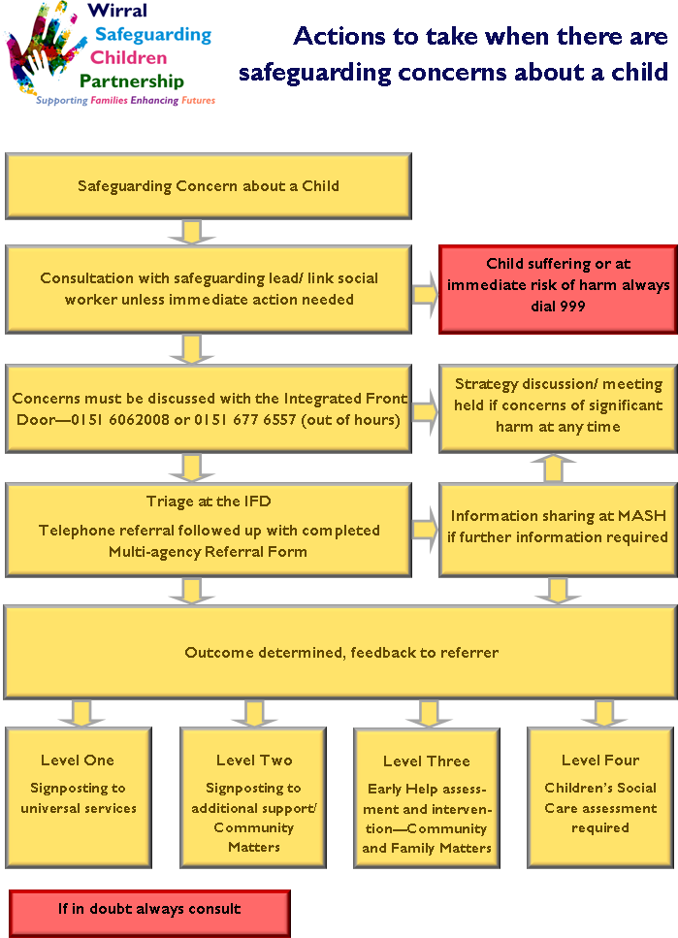
Appendix D – Flowcharts and LSCP Information
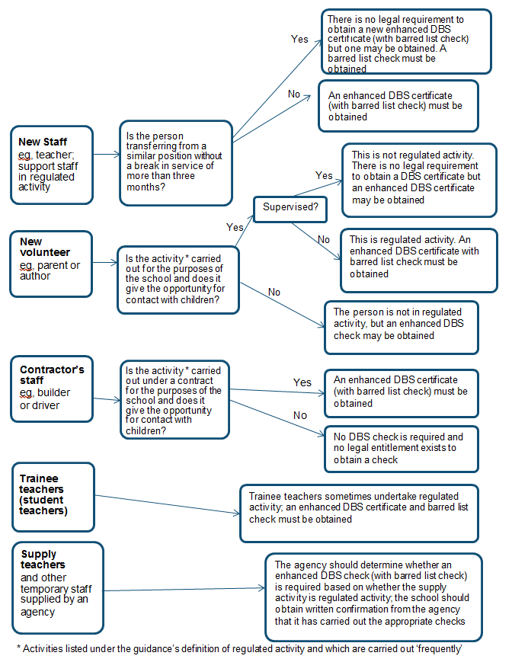

Wirral Social Care has produced diagrams which are attached as a separate appendix, as follows:
- Safeguarding Children
- Sexting
- Contextual Safeguarding
- Briefing: Supporting Families Enhancing Futures
- Briefing: Professional Disagreement & Escalation
- Briefing: Child Sexual Exploitation
- Briefing: Private Fostering
- Early Help

- Social Media and Mental Health
- Missing Children Procedure
- Adverse Childhood Experiences (ACEs)
- Anderson Children Multi-Agency Learning Review
- County Lines
- Briefing: Neglect
- Briefing: Harmful Sexual Behaviour (HSB)
- Briefing: Domestic Abuse

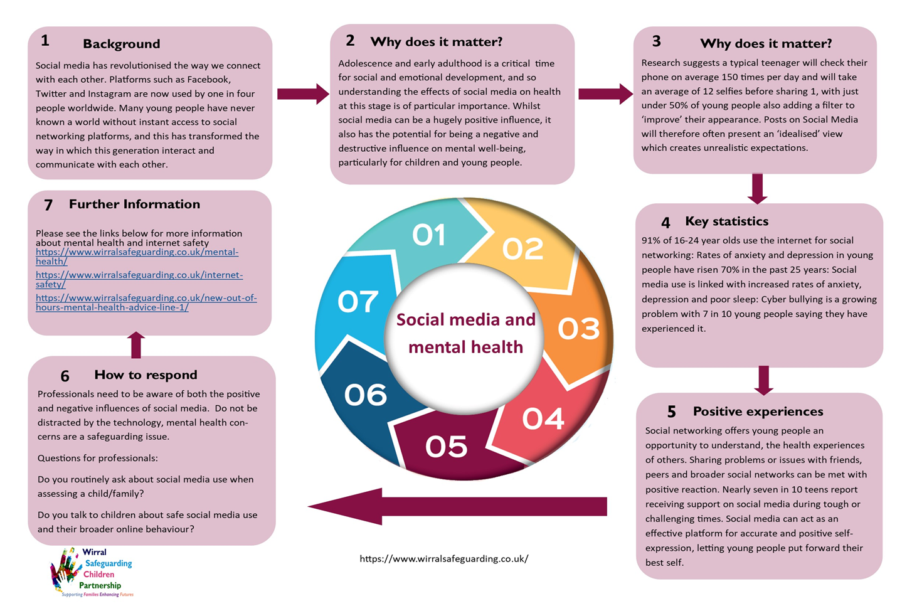
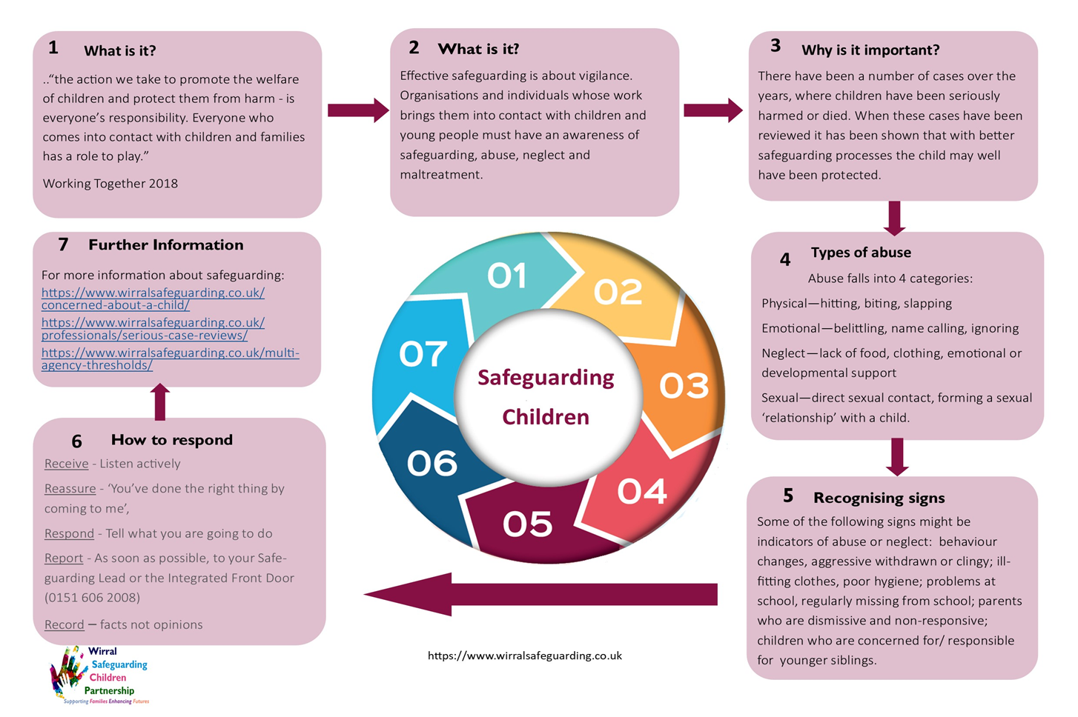

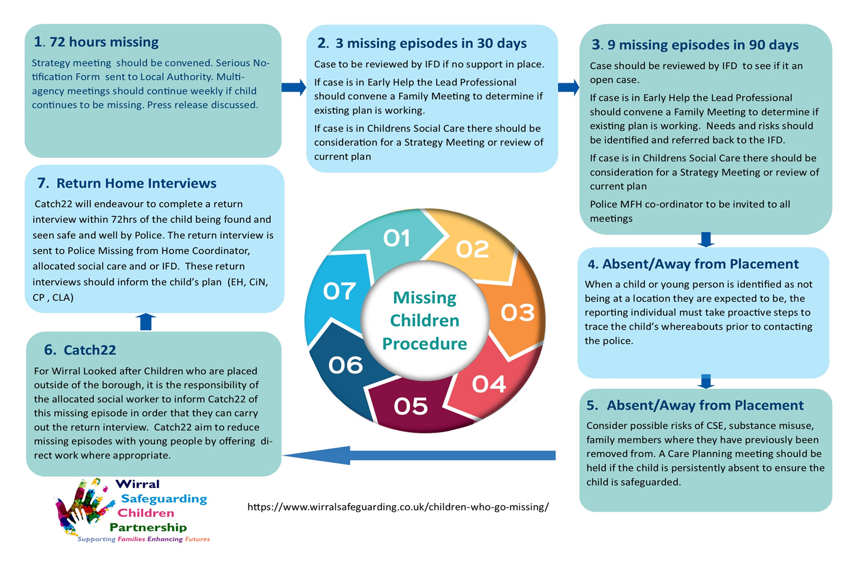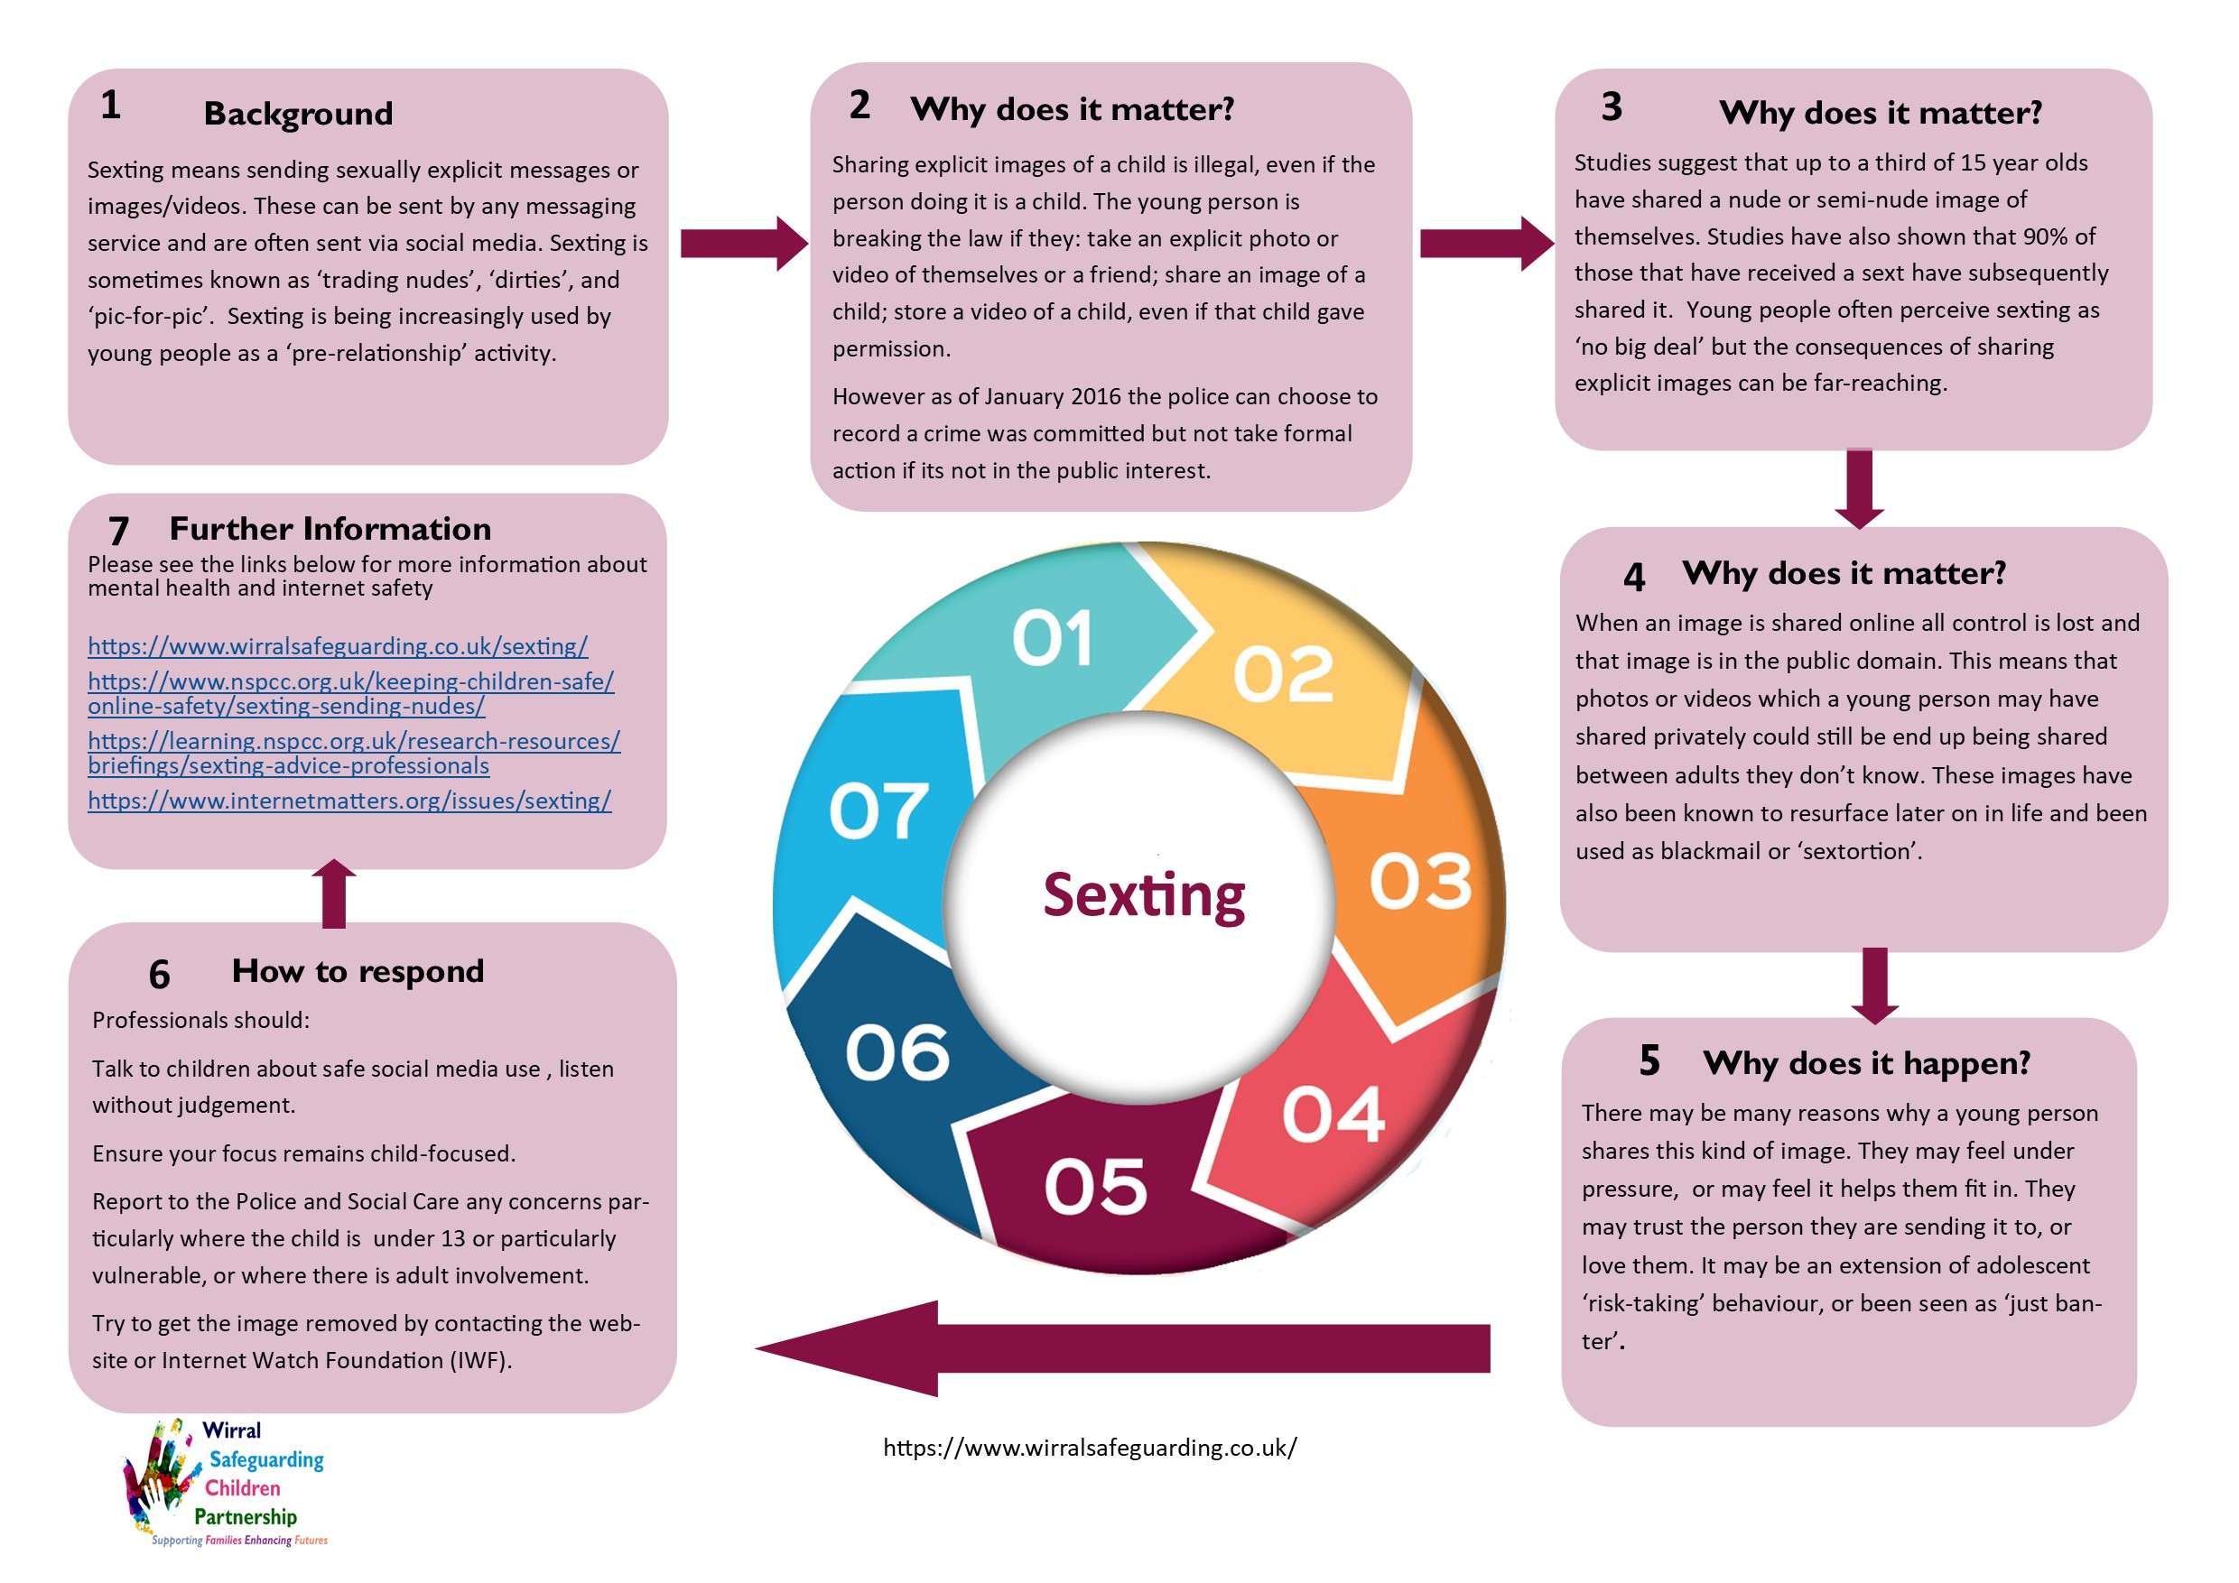

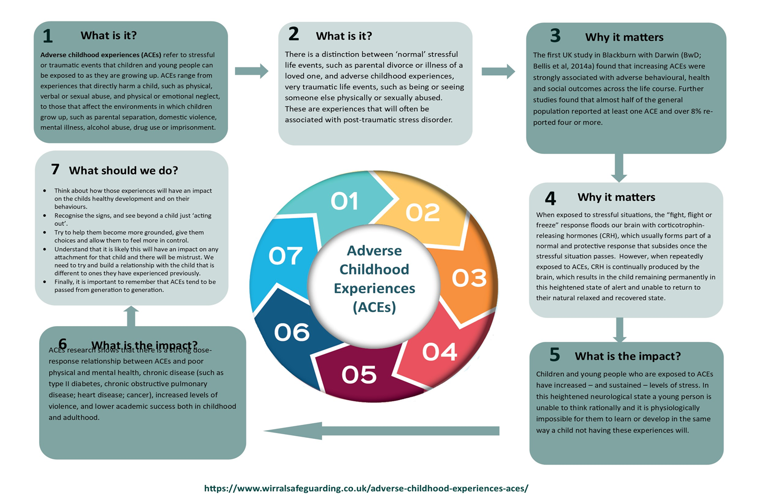
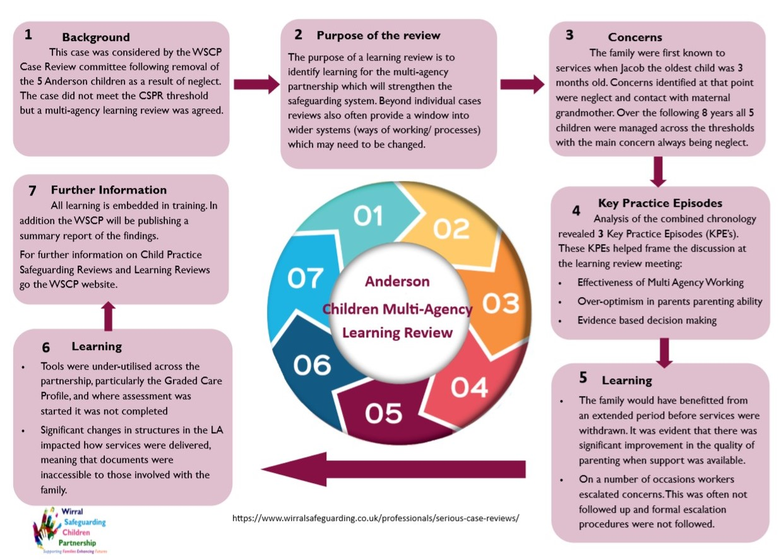

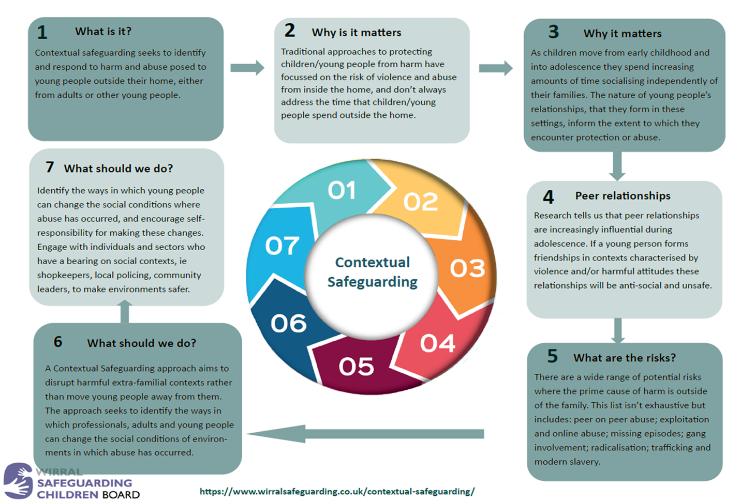
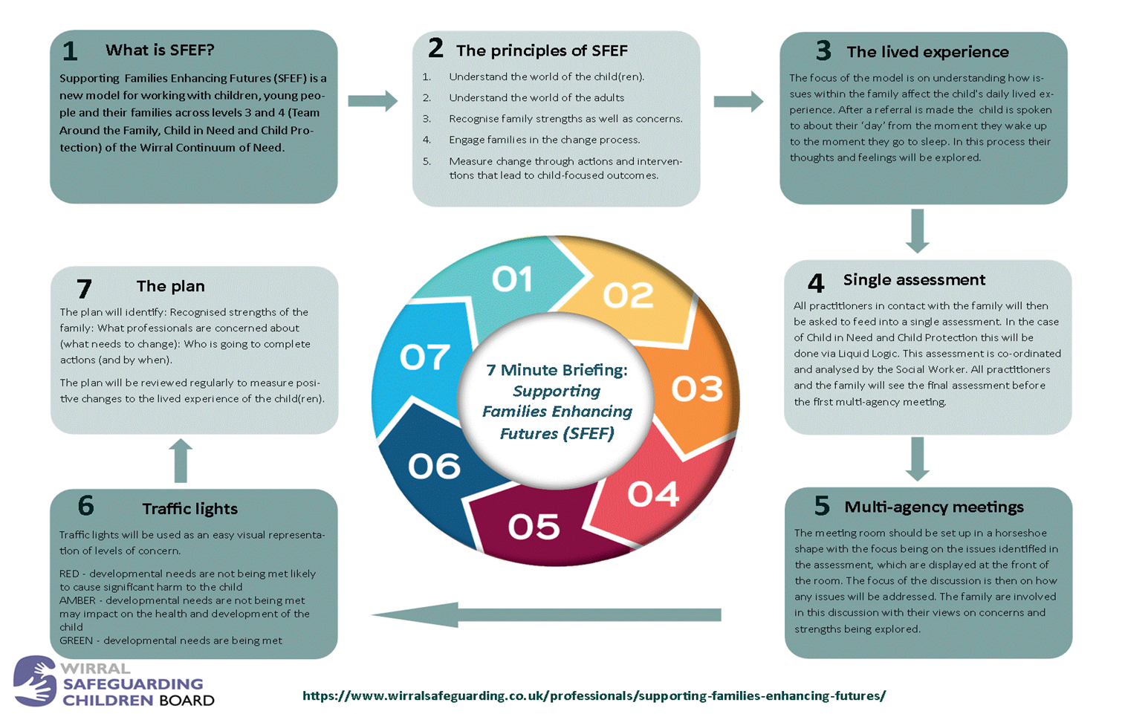

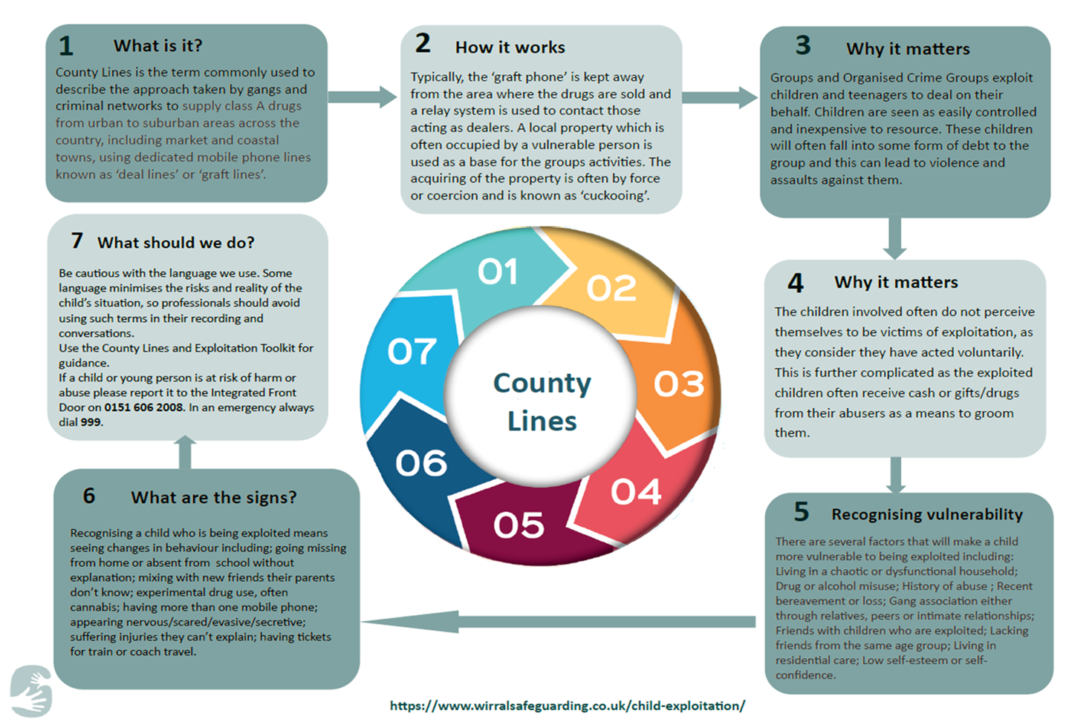

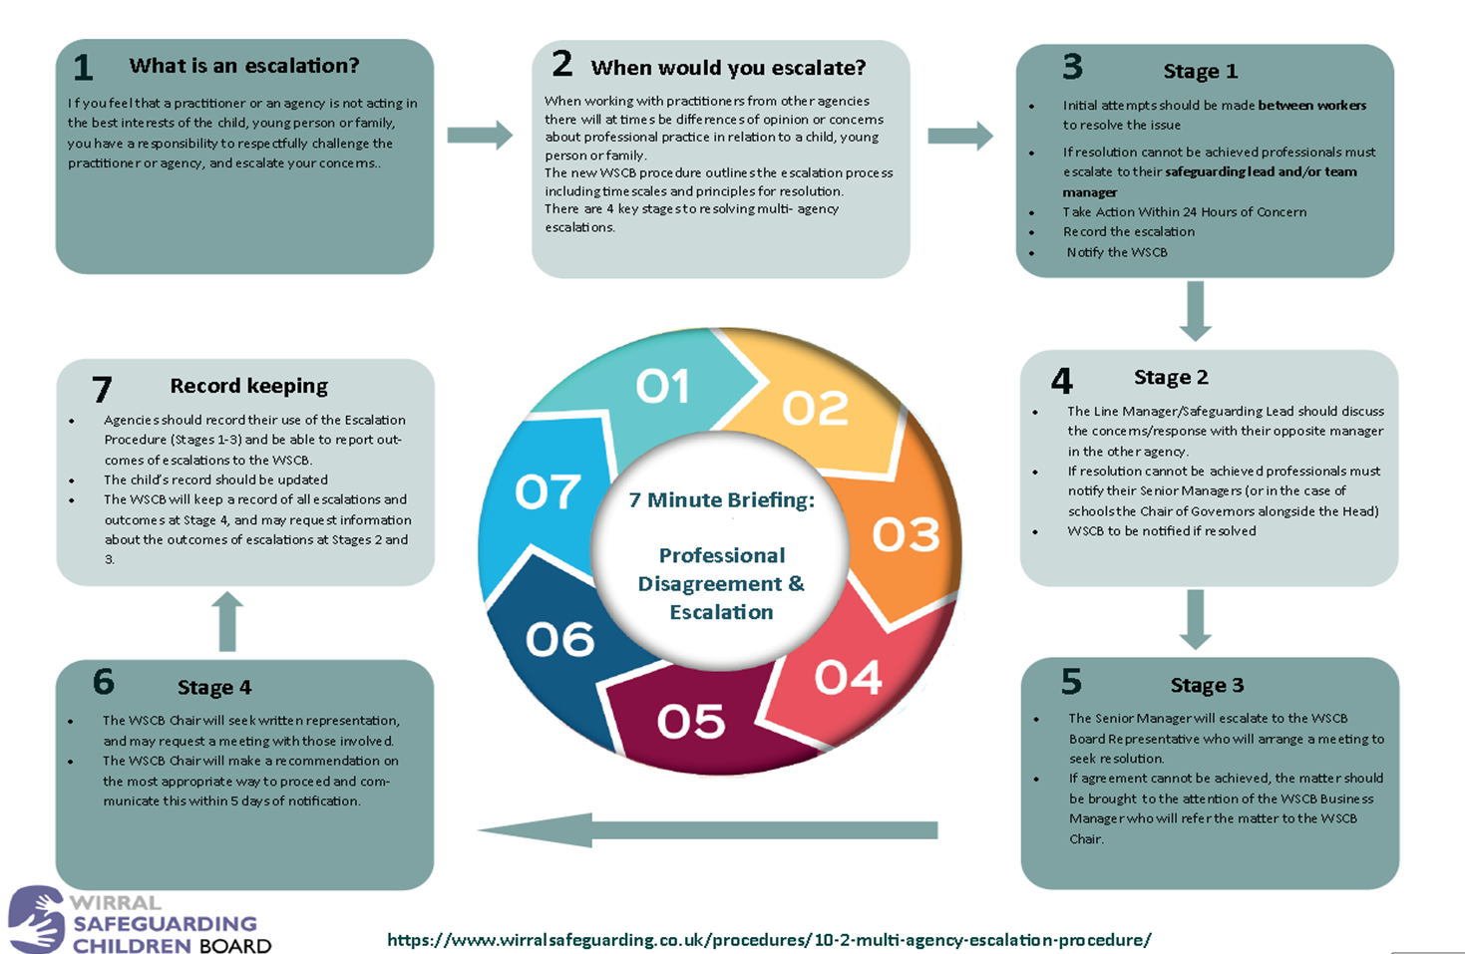

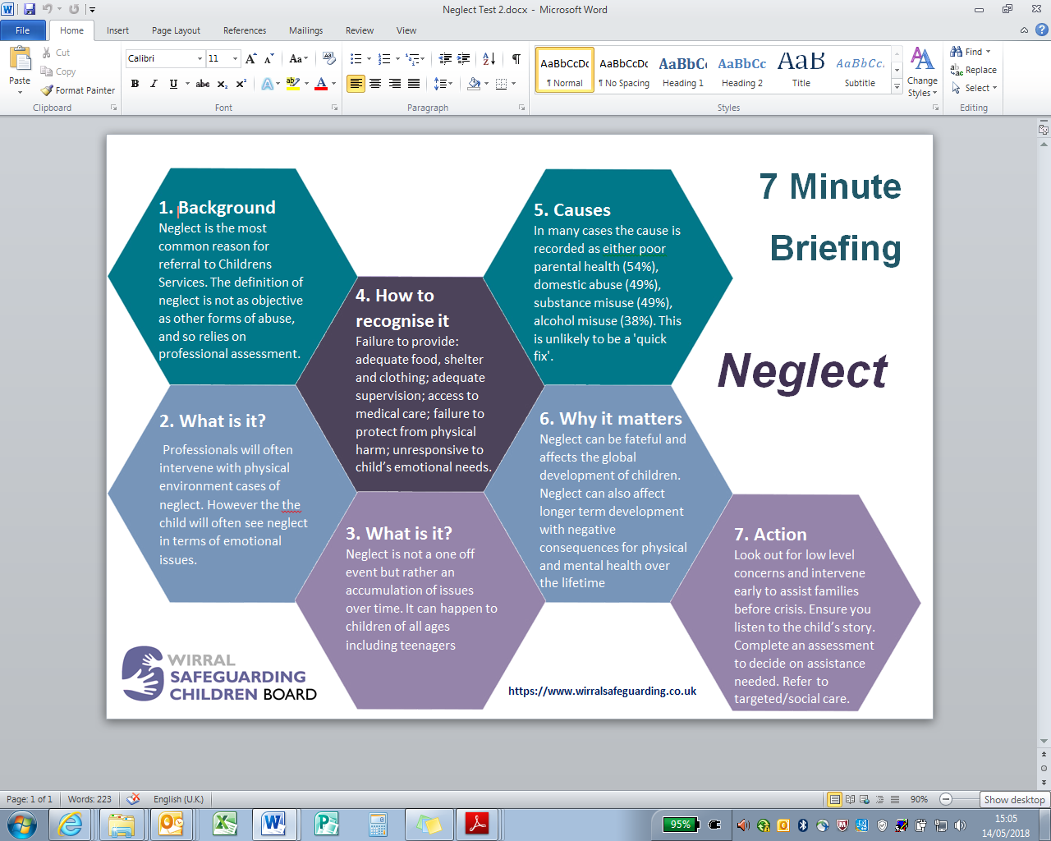

THE ORGANISATION AND RELATIONSHIP OF SAFEGUARDING AND PASTORAL CARE POLICIES AND
PROCEDURES AT LIFE Wirral Sports School

Ensuring that our community is collectively responsible and able to ensure that we keep our pupils safe at all times is fundamental aim for our School. LIFE Wirral Sports School has developed a series of Policies and Procedures that are intended to support this endeavour. The following diagram illustrates the inter-relationship of these Policies.

Online Safety Policy

Anti-Bullying Policy
Mental Health Policy

Spiritual, Moral, Social & Cultural Development Policy
Behaviour Management Policy
Child protection and Safeguarding Policy

Relationship & Sex Education Policy
Preventing Extremism & Radicalisation Policy

Personal, Social, Health & Economic Education Policy

Staff Behaviour Policy (Code of Conduct)
Special Educational Needs (SEND) Policy

ADDITIONAL ADVICE AND SUPPORT:
The following is not exhaustive but does provide a useful starting point.

Abuse
Supporting practice in tackling child sexual abuse - CSA Centre Expertise on Student Sexual Abuse
What to do if you're worried a child is being abused – DfE advice Domestic abuse: Various Information/Guidance - Home Office (HO) Faith based abuse: National Action Plan - DfE advice
Disrespect NoBody campaign - GOV.UK - Home Office website paper Together we can stop child sexual abuse – HM Gov.

Bullying
Preventing bullying including cyberbullying - DfE advice

Children missing from education, home or care
Children missing education - DfE statutory guidance Children missing from home or care - DfE statutory guidance
Trafficking: safeguarding Children - DfE and Home Office guidance; Modern slavery: how to identify and support victims –Child exploitation disruption toolkit - HO statutory guidance; County Lines Toolkit For Professionals - The Children's Society

Confidentiality
Gillick competency Fraser guidelines - Guidelines to help with balancing Children’s rights along with safeguarding

Drugs
Drug strategy 2021 - Home Office strategy Information and advice on drugs - Talk to Frank website
Drug and Alcohol education — teacher guidance & evidence review – PSHE Association

(so called) “Honour Based Abuse” including FGM and forced marriage
Female genital mutilation: multi agency statutory guidance - DfE, DoH, HO Forced marriage - FGM resource pack –

Health and Well-being
Rise Above: Free PSHE resources on health, wellbeing and resilience - Public Health England
Supporting pupils at schools with medical conditions - DfE statutory guidance Mental health and behaviour in schools - DfE advice; Overview - Fabricated or induced illness - NHS advice
Government information sharing advice - Guidance on information sharing for people who provide safeguarding services to children, young people, parents and carers.
Information Commissioner's Office: Data sharing information hub

Online safety-advice
Childnet provide guidance for schools on cyberbullying
Educate against hate provides practical advice and support on protecting students from extremism and radicalisation
London Grid for Learning provides advice on all aspects of a school or college’s online safety arrangements
NSPCC E-safety for schools provides advice, templates, and tools on all aspects of online safety arrangements
Safer recruitment consortium “guidance which may help ensure staff behaviour policies are robust and effective
Searching screening and confiscation advice on searching students and confiscating items such as mobile phones
South West Grid for Learning provides advice on all aspects of a school or college’s online safety arrangements
Use of social media for online radicalisation - A briefing note for schools on how social media is used to encourage travel to Syria and Iraq
Online Safety Audit Tool from UK Council for Internet Safety

Online safety- Remote education, virtual lessons and live streaming
Guidance Get help with remote education h other resources and support for teachers and school leaders
Departmental guidance on safeguarding and remote education including planning remote education strategies London Grid for Learning guidance, including platform specific advice
National cyber security centre guidance on configuring and deploying video conferencing; UK Safer Internet Centre

Online Safety- Support for students
Childline;UK Safer Internet Centre to report and remove harmful online content CEOP for advice on making report

Online safety- Parental support
Childnet offers a toolkit to support parents and carers of students of any age to start discussions about their online
Commonsensemedia independent reviews, age ratings, about all types of media for students and their parents
Government advice protecting students from online harms such as student sexual abuse, sexting, and cyberbullying
Internet Matters age-specific online safety checklists, guides on how to set parental controls, and practical tips
How Can I Help My Child? Marie Collins Foundation – Sexual Abuse Online
Let’s Talk About It provides advice for parents and carers to keep students safe from online radicalisation
London Grid for Learning provides support for parents and carers to keep their students safe online,
Stopitnow from The Lucy Faithfull Foundation concerned about someone’s behaviour, including students
National Crime Agency/CEOP Thinkuknow provides support for parents and carers to keep their students safe online
Net-aware support for parents and carers from the NSPCC and O2, a guide to social networks, apps and games
Parentzone provides help for parents and carers on how to keep their students safe online
Talking to your Child about online sexual harassment: A guide for parents –Children’s Commissioner’s parent guide
#Ask the awkward – Student Exploitation and Online Protection Centre guidance to parents to talk to their students

Private fostering
Private fostering: local authorities - DfE statutory guidance

Radicalisation
Prevent duty guidance- Home Office; Prevent duty: additional advice for schools and studentcare providers ; Educate Against Hate website; Prevent for FE and Training - Education and Training Foundation (ETF)Extremism and Radicalisation Safeguarding Resources – Resources by London Grid for Learning

Serous Violence
Factors linked to serious violence and how these factors can be used to identify individuals for intervention – Home Office
Youth Endowment Fund – Home Office; Gangs and youth violence: for schools and colleges - Home Office advice Tackling violence against women and girls strategy-; Violence against women and girls: national statement of expectations for victims -

Sexual violence and sexual harassment Specialist Organisations
Barnardo's ; Lucy Faithful Foundation - UK-wide child protection charity dedicated to preventing student sexual abuse.
Marie Collins Foundation –works directly with students, and families to enable their recovery following sexual abuse.
NSPCC - specialising in child protection with statutory powers to safeguard children at risk of abuse.
UK Safer Internet Centre -advice and support to students, young people, parents, carers a about staying safe online.

Harmful sexual behaviour
Rape Crisis (England & Wales) or The Survivors Trust for information, advice, and details of local specialist sexual violence
NICE guidance developing interventions working with families and carers; and multi-agency working.
HSB toolkit The Lucy Faithfull Foundation - designed for parents, carers, family members and professionals
NSPCC Learning: Protecting students from harmful sexual behaviour and NSPCC - Harmful sexual behaviour framework; Contextual Safeguarding Network – Beyond Referrals (Schools) self- assessment toolkit and guidance
Preventing harmful sexual behaviour in students - Stop It Now provides a guide for parents, carers and professionals

Support for Victims
Anti-Bullying Alliance - Detailed information for anyone being bullied, along with advice for parents and schools.
Rape Crisis - services to support people who have experienced rape, student abuse or any kind of sexual violence.
The Survivors Trust- UK-wide national umbrella agency with resources and support dedicated to survivors of rape, sexual violence and student sex abuse; .Victim Support - Supporting students and young people who have been affected by crime; Childline provides free and confidential advice for students and young people.

Toolkits
ask AVA - The Ask AVA prevention platform has been created to support education practitioners across the UK to develop and deliver a comprehensive programme to stop Violence Against Women and Girls.
NSPCC - Online Self-assessment tool to ensure organisations are doing everything they can to safeguard children.
NSPCC - Resources which help adults respond to students disclosing abuse.
NSPCC also provides free and independent advice about HSB: NSPCC - Harmful sexual behaviour framework
Safeguarding Unit, Farrer and Co. and Carlene Firmin, MBE, University of Bedfordshire - Child-on-Child Abuse
Contextual Safeguarding Network – self-assessment toolkit for schools to assess their own response to HSB.
Childnet - STAR SEND Toolkit equips, enables and empowers educators with the knowledge to support young people with special educational needs and disabilities.
Childnet - Just a joke? provides lesson plans, activities, a quiz and teaching guide designed to explore problematic online sexual behaviour with 9-12 year olds.; Childnet - Step Up, Speak Up a to online sexual harassment amongst young people aged 13-17 years old.
NSPCC - Harmful sexual behaviour framework An evidence-informed framework for students and young people displaying HSB.
Contextual Safeguarding Network – Beyond Referrals - Schools levers for addressing HSB in schools.

Sharing nudes and semi-nudes
London Grid for Learning-collection of advice - information and resources re the sharing of nudes and semi-nudes.
UKCIS Sharing nudes and semi-nudes: advice for education settings working with students and young people - Advice for schools and colleges on responding to incidents of non-consensual sharing of nudes and semi-nudes.

Support for parents/carers; NCA CEOP Thinkuknow: what students may be doing online including advice on how to help challenge harmful sexual attitudes and start a conversation to support positive sexual behaviour|

